

Annual Report
2018 Green Hospital Scorecard Report
This annual report is intended to visualize and discuss the results from the 2018 Green Hospital Scorecard. The Canadian Coalition for Green Health Care operates this free program as a means for hospitals to measure and monitor their environmental progress
Abstract
Sponsors
The Green Hospital Scorecard is a comprehensive tool for health care providers across Canada and is entering it’s 7th year of operation. Through the support of various organisations, the Canadian Coalition for Green Health Care has been able to support hospitals to gain an awareness of their environmental impact.

We want to say thank you to IESO’s program Save on Energy for sponsoring our Energy and Energy Behaviour Awards. If your organisation is interested in becoming a sponsor for our upcoming Green Hospital Scorecard awards, email our Executive Director Neil Ritchie at neil.ritchie@greenhealthcare.ca.



Authors
The primary authors of this report are Coalition staff and contractors:
- Shawn Shi, P.Eng., who oversaw the software component of the survey data;
- Robert Hanley, BSc. who undertook data verification, analysis and created numerous graphs;
- Dan Ritchie, MSc., who created graphs and wrote much of the text; and
- Linda Varangu, MEng., who edited and reviewed the document.
For more information about this report, please contact the Executive Director Neil Ritchie at neil.ritchie@greenhealthcare.ca.

Contents
1. Introduction 5
1.1 Overview of the Health Care Sector in Canada 5
1.2 Background on the Green Hospital Scorecard 6
1.3 Green Hospital Scorecard 6
1.4 Methodology 6
Survey design 7
Distribution 7
Response 8
2. 2018 GHS Top Performers 9
Highest Energy Scores - Sponsored by SaveOnEnergy 9
Highest Water Scores 10
Highest Waste Scores 10
3. Program Details 10
1.1 Peer Groups 11
1.2 Number of Beds 12
3.3 Hospital Participation over Previous Years 13
4. General Information and Sector Summaries 15
4.1 General Information 15
4.2 Sector Summaries 15
5. Building Energy and Building Greenhouse Gas Emissions 17
5.1 Background 17
5.2 Results 18
5.2.1 Energy Use by Type 18
5.2.2 Energy Use Intensities 20
5.2.3 Monitoring and Management 22
5.2.4 Energy Leadership, Initiatives and Innovations 22
5.2.6 Building Energy Use CO₂ Equivalencies 26
6. Water 27
6.1 Background 27
6.2 Results 28
6.2.1 Water Use Intensity 29
6.2.2 Water Conservation Leadership, Initiatives and Innovations 30
7. Waste 32
7.1 Background 32
7.2 Results 33
7.2.1 Waste Generation by Type 35
7.2.2 Waste Use Intensity 36
7.2.3 Waste Management Leadership, Initiatives and Innovations 37
8. Pollution Prevention 39
8.1 Background 39
8.2 Results 39
8.2.1 Toxins Management Initiatives 40
8.2.2 Sustainable Construction/ Renovation Initiatives 41
8.2.3 Other Pollution Prevention Initiatives 43
9. Corporate Leadership, Planning and Management 44
9.1 Background 44
9.2 Results 44
9.2.1 Corporate Leadership 44
9.2.2 Programming 45
The following programming areas were revealed in the data analysis: 45
9.2.3 Planning 45
9.2.4 Monitoring and Management 46
10. Transportation 47
10.1 Background 47
10.2 Results 47
10.2.1 Zero Emission Vehicles 47
10.2.2 Telemedicine 48
11. Food 50
11.1 Results 50
11.1.1 Food Policies 50
12. Climate Change 54
12.1 Results 55
12.1.1 Recognition of climate change as an issue of concern 55
12.2.1 Climate-related events affecting hospitals 56
12.2.2 Climate-related impacts on hospitals 57
12.2.3 Resiliency and Vulnerability Assessments 58
13. Energy Behavior 59
13.1 Background 59
13.2 Results 59
13.2.1 Energy Behaviour Awareness 59
13.2.3 Self-ranking of Energy Behaviour Integration at Facility 61
13.2.4 Energy Behaviour Award 62
14. Conclusion 63
Appendices 64
Appendix A - GHS questionnaire 64

Introduction

Overview of the Health Care Sector in Canada
Hospitals provide health services 24 hours a day, seven days a week, and in the process consume products and natural resources which result in a significant environmental footprint. The sector uses considerable energy; consumes large quantities of plastics, paper and other resources; and produces significant solid, liquid and gaseous waste. For example, Canada’s health care system is estimated to emit more than 210,000 metric tonnes of non-GHG pollution in the air, water and soils. With the improvement of health care technologies and a growing awareness of environmentally responsible practices, there is an increased opportunity for reducing the health sector’s environmental footprint. Environmental contaminants have been associated with compromised health status, including cancer, birth defects, respiratory and cardiovascular illness, gastrointestinal ailments and death — and an increased demand for a range of health care services. Although there are important health, financial and ethical reasons for adopting such practices in the health sector, a number of challenges exist, including financial, technical and administrative.

The health sector is a significant part of Canada’s economy, contributing approximately 11.3% of gross domestic product (GDP) and utilizing $253.5 billion dollars nationally in 2018. Hospital costs were the largest component of this expenditure (28.3%), followed by pharmaceuticals (15.7%), and physician fees for services (15.1%). Across Canada, health sector spending represents the largest budgetary outlay for every provincial and territorial governments. Hospitals are often one of the largest employers in a community with a health and social services workforce of 1.9 million Canadians in 2019 and employ the most trusted of all professions – nurses and doctors.

In 2018-2019 there were 628 hospitals across Canada with 91,375 hospital beds.

Background on the Green Hospital Scorecard
In 2013, the Ontario Hospital Association (OHA) developed the Green Hospital Scorecard (GHS) with a steering committee of hospital staff and health care experts. The OHA administered the GHS through the Green Hospital Champion Fund program and funding support from the Ontario Ministry of Consumer and Government Services. Once the OHA program ended in 2016, the Canadian Coalition for Green Health Care (The Coalition) was asked to continue the delivery of the GHS program. The Coalition has been a historic collaborator with the OHA on the development of the GHS since its inception and as well as the annual Green Health Care Awards. The 2018 GHS program is the sixth year that the GHS program has been offered.

Green Hospital Scorecard
The GHS is a benchmarking and recognition tool measuring hospital’s energy conservation, water conservation, waste management, pollution prevention, and corporate leadership, planning and management. This year saw the introduction of 4 new categories, including transportation, food, climate change and energy behaviour. Participating hospitals report on their environmental and sustainability initiatives through the online GHS survey, receive a scorecard summarizing their environmental performance, and receive a Gold, Silver or Bronze rating, relative to their peers. The program allows for enhancement of existing benchmarking data, refinement of collection methodologies and the creation of meaningful reporting data to inform the hospitals and its executives. The purpose of the scorecard is to raise the hospital’s awareness, motivate behavioural change for future conservation efforts, and incite improvements in the environmental initiatives by recognizing each hospital’s achievements. The GHS also:
- Provides detailed analysis of the organization’s environmental performance against a backdrop of de-identified peer data;
- Supports identifying potential areas for improvements to environmental performance and operational efficiency;
- Creates a benchmarking platform for hospitals to compare efficiencies;
- Offers the opportunity to be individually recognized through annual Gold, Silver and Bronze level achievements; and
- Encourages excellence in environmental performance by honouring select participating organizations with annual Green Health Awards.

When discussing the data selected within each GHS program, it uses the following conventions when referring to different years of the program:
- 2018 GHS Program will report on data for the 2017 calendar year (January to December)
- 2017 GHS Program will report on data for the 2016 calendar year (January to December)

Methodology
The methodology for developing the 2018 GHS participant’s environmental performance results included survey design, distribution, response and analysis.

Survey design
The GHS survey included questions organized into ten main sections (see Appendix A for the questionnaire).
Section | Focus
General Information | General information about the hospital site and contact information
Energy section | Energy consumption, type of energy usage, conservation initiatives and their benefits.
Water section | Water consumption, both for buildings and ground maintenance, billing information, conservation initiatives and their benefits.
Waste section | Type of waste, recycling, disposal methods, as well as, waste reduction initiatives and their benefits.
Pollution Prevention | Policy, targets, action plans and initiatives and their benefits.
Corporate Leadership, Planning and Management | Policies, action plans and outreach programs.
Transportation | Active and clean energy initiatives and infrastructure, along with adoption of telemedicine.
Food | Healthy food policies, along with food procurement, and perceived barriers.
Climate Change | Management policies affects and experiences around Climate Change related events and vulnerability assessment.
Energy Behaviour | Staff engagement and awareness, along with energy conservation policies and programs.

Table 1: 2018 Green Hospital Scorecard survey design

Distribution
The survey is set up on the web-based platform, Cognito Forms and was available in English and French. The survey was promoted via direct email invitations to past participants of the program, as well as potential participants that had expressed interest in previous scorecards but had yet to participate. The survey was also promoted through the Coalition’s newsletter, The Green Digest, direct email to other Coalition program participants, and social media channels, including Twitter and Facebook. In addition, Coalition partners and supporters such as the Ontario Hospital Association (OHA), the Canadian Healthcare Engineering Society (CHES) and the Ontario Healthcare Housekeeping Association (OHHA) also promoted participation in the GHS to their networks.

Response
There was a total of 101 responses from this year’s GHS program. With ongoing communications with various Canadian health care providers, the survey was distributed and completed by hospitals of various scales from across Canada.
Analysis
This report is based on a descriptive analysis of the survey data, including a content analysis of the free-text answers. The quantitative questions were analyzed using descriptive statistics and visualized using Excel. The qualitative questions were analyzed using content analysis, frequently mentioned themes and other content were derived and summarized. The information presented in this report was compiled and interpreted exclusively for the purpose of this GHS document. The Coalition exercised reasonable skill, and consideration in order to validate all data acquired during the preparation of the report but makes no warranties as to the accuracy or completeness of the information. The information contained in this report is based upon data and insights provided by the GHS participants, which is believed to be accurate but cannot be fully guaranteed.

2018 GHS Top Performers

The 2018 GHS program recognized the following top performers in each category and peer group:


Highest Overall Scores
- Highest Overall Scores - Green Hospital of the Year Awards
- Michael Garron Hospital (Community)
- University Health Network - Toronto Rehab (Academic)
- West Park Healthcare Centre (Non-Acute)
- Kemptville District Hospital (Small)



Highest Energy Scores - Sponsored by Save on Energy
- Hamilton Health Services- St. Peter's Hospital (Community)
- University Health Network - Princess Margaret (Academic)
- St. Joseph's Health Care, London - Parkwood RMHC (Non-Acute)
- Kemptville District Hospital (Small)

Energy Behaviour Award - Sponsored by Save on Energy
- Winner: London Health Sciences Centre - Victoria Hospital
- Honorable Mention: University Health Network
- Honorable Mention: St. Joseph’s Healthcare, London



Highest Water Scores
- The Ottawa Hospital - General Hospital (Community)
- St. Michael's Hospital - Main Building, Bond Street (Academic)
- St. Joseph's Health Care, London - Parkwood RMHC (Non-Acute)
- Four Counties Health Services (Small)



Highest Waste Scores
- Northumberland Hills Hospital (Community)
- Trillium Health Partners - Queensway Health Centre (Academic)
- Holland Bloorview Kids Rehabilitation Hospital (Non-Acute)
- Kemptville District Hospital (Small)

Program Details

Over the six years of the GHS program, the survey has been shifting and evolving.
In the 2018 GHS, 101 hospital sites participated in the survey, with the majority of participants from Ontario, with some from other Canadian provinces as far west as British Columbia, and as east as Nova Scotia. The goal of the program is to encourage facilities from across the country, and outside of Canada to participate. The following Figures explore participation within the GHS program. Below, Figure 1 shows the number of new vs returning participants.
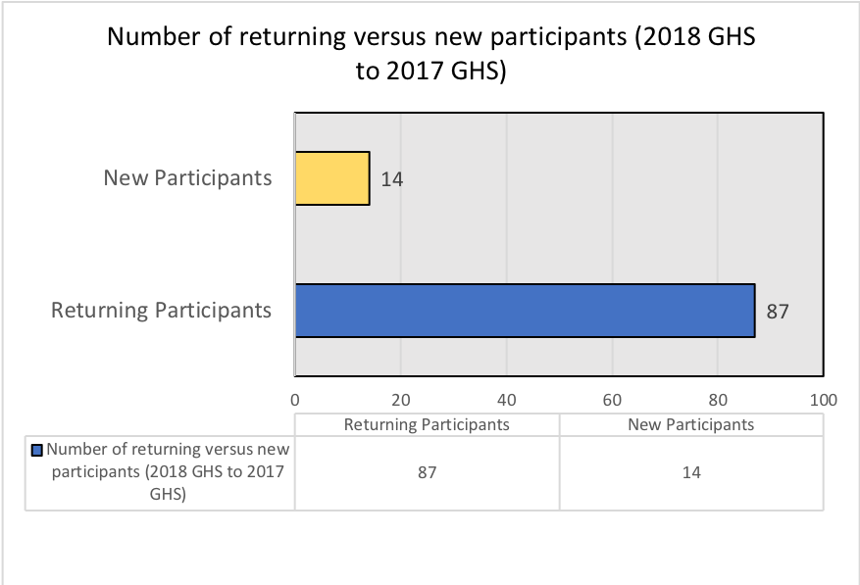
Canadian Coalition for Green Health Care, 2018

Figure 1. 2018 GHS new vs returning participants

Peer Groups
Each year, GHS participants are asked to identify as one of four peer groups:
- Community Hospitals: Acute care hospitals that do not fit the definition of a small or academic (teaching) hospital.
- Academic Hospitals: All acute general and pediatric hospitals that are members of the Council of Academic Hospitals of Ontario (CAHO).
- Non-Acute Hospitals: Complex Continuing Care (CCC), rehabilitation, and mental health hospitals. Have standalone CCC or Rehabilitation beds. They may or may not be members of CAHO.
- Small Hospitals: Provides less than 3,500 weighted cases, have a referral population of less than 20,000, and is the only hospital in the community.

Participating sites represent academic, community, non-acute and small hospitals, and included in those categories are other associated facilities such as outpatient clinics, mental health facilities, and research buildings. Figure 2 shows the percent of participants in each peer group.

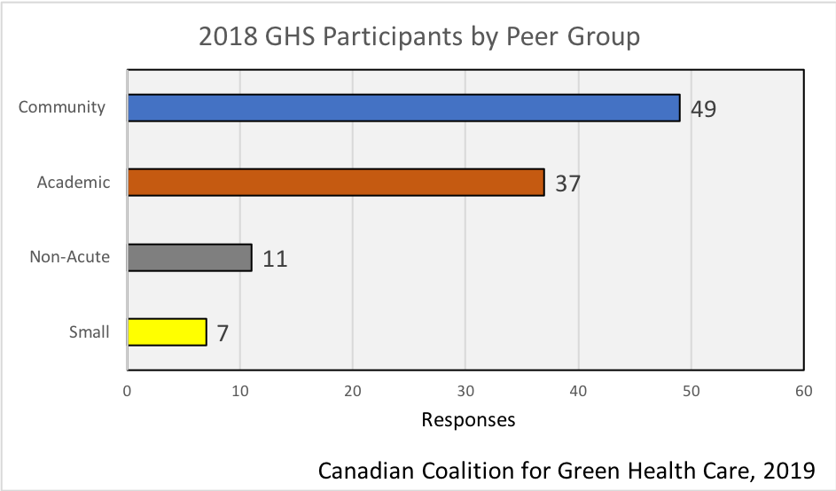

Figure 2: 2018 GHS participants by peer group (percentage)

Number of Beds
Each year the participants are asked to provide the number of beds within each of their hospital sites. The sites that included a bed count of zero (0) indicated the nature of their operations as either outpatient clinic or administrative buildings. A total of 10 sites identified having a 0-bed count. Figure 3 shows the range of bed counts for all sites, with the most frequently cited (22) between 1 and 99 beds, and 40% of the sites had between 1 and 199 beds.
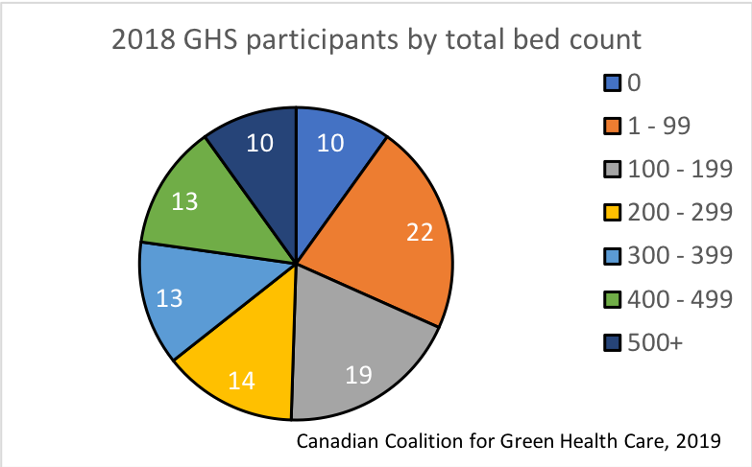

Figure 3: 2018 GHS participants by total bed count.

3.3 Hospital Participation over Previous Years
Over the previous six years, participation in the GHS had a gradual increasing trend with minor variance from year to year. This past scorecard had a slight decline of 9 hospitals from the previous year. More hospitals from outside of Ontario and internationally have participated in the survey allowing for a broader spectrum of benchmarking comparisons. Figure 4 shows the number of GHS participants over the last six years by peer group.
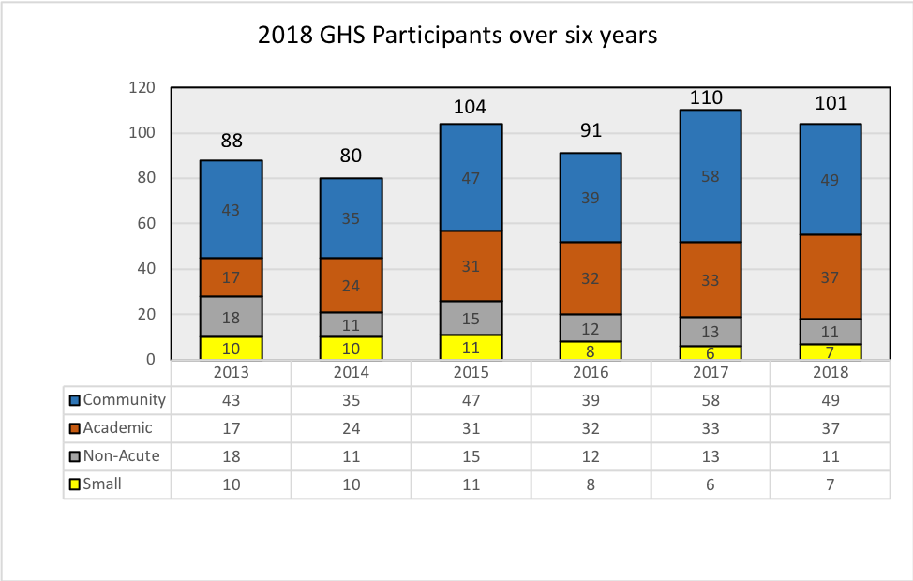
Canadian Coalition for Green Health Care, 2018
Figure 4: GHS Participants over six years by peer group

General Information and Sector Summaries

4.1 General Information
The General Information section of the survey collects data on the hospital site, its area, number of beds, inpatient days, outpatient visits and contact information. Each hospital provides data throughout the various sectors highlighted in the scorecard consistently with these figures and only inclusive of conditioned buildings at the site. Similar to the previous scorecard, organizations with multiple hospital sites were required to generate a unique survey for each site.
Within the general information category there were several questions pertaining to the following five listed areas, as shown in Table 2.

General Information | Summary
Conditioned floor area | Conditioned floor area is restricted to climate- controlled areas excluding underground parking and other large, maintained areas that are not common to all hospitals.  Area includes all medical buildings as well as non-medical buildings if data for these buildings were reported throughout the survey.
Number of beds | Each hospital provides the number of beds in place during 2017.  For those hospitals that had a bed count of zero (0) it indicates that it is another type of building such as outpatient clinic, administration or research building.
Inpatient days | The days during which services are provided to an inpatient where the day of admission is counted as an inpatient day but the day of separation is not.  When the service recipient is admitted and separation on the same day, one inpatient day is counted.
Outpatient visits | A patient who is not hospitalized overnight but who visits a hospital, clinic, or associated facility for diagnosis or treatment.  It includes ambulatory visits (ER), day surgeries or surgical cases and any face to face visits.
Contact information | First and last name, email address, phone number and title.

Table 2: General information from GHS survey

4.2 Sector Summaries
GHS sector reports provide a summary of a hospital’s environmental performance and are comprised of the five main sections of the GHS survey: Energy, Water, Waste, Pollution Prevention, and Corporate Leadership, Planning, and Management, Transportation, Food, Climate Change and Energy Behaviour. Sector data entries are collected, analysed and presented annually and by peer groups (Academic, Non-Acute, Community, and Small), and represent the averages for the hospital sites that participated in the GHS. The sector and peer group averages might show an increase or decrease from one year to the next as the organizations participating in the program may differ slightly each year. Table 3 provides an overview of each of the sector summaries.

Sector Summary | Content/Purpose
Energy | Summarizes participant’s energy use and sources, and considers the greenhouse gas implication of participant’s energy use.
Water | Summarizes water use and management.
Waste | Summarizes waste management activities.
Pollution prevention | Summarizes organization’s commitments to purchase less toxic and more environmentally preferred materials for use within the hospital, and consideration of the impacts of building construction on the environment and within the hospital.
Corporate leadership, planning and management | Summarizes measures that capture hospital’s corporate commitment to an environmentally sustainable culture and integration of green objectives into corporate planning and regular business.
Transportation | Summarizes transportation initiatives such as Electric Vehicle infrastructure within sites and telemedicine.
Food | Summarizes initiatives focusing on healthy food systems, these include meat-based alternatives, local food procurement and food waste management.
Climate Change | Summarizes climate change policy, extreme weather events, along with hospital adaptation and response.
Energy Behavior | Summarizes organization’s understanding and adoption of energy behavior.

Table 3: Sector summaries overview

Building Energy and Building Greenhouse Gas Emissions

5.1 Background
The Canadian hospital sector has the highest energy intensity within the commercial and institutional sectors. Canadian hospitals accounted for 538,031 terajoules or 11% of non-business, non-household energy use in Canada in 2008 and 21,228 carbon dioxide equivalents or 8% of greenhouse gas (GHG) emissions of non-business or household emissions. In a more recent report, the Canadian health system has been estimated to contribute approximately 5% of Canada’s GHG emissions but this value includes GHG emissions beyond just hospital building energy use. For more information on the GHG emissions from sources other than building energy see Section 12 on Climate Change in this report.

Where and how energy is used can vary by site, but generally the usage hierarchy follows the itemized list below, in order of magnitude:
- space heating
- auxiliary equipment
- auxiliary motors
- lighting / water heating, and
- space cooling
As illustrated in Table 4, the hospital sector has an aging infrastructure, with over 40% of hospital buildings over 51 years since the year of construction. This age of facility accounts for over 50% of the floor space. Note that the total number of hospitals reported in this table is 798 hospitals which is higher than the 2018 number of 628 hospitals due to a difference in the year of the reports.

Hospitals
Year of Construction | # Buildings | Floor Space  (millions m²) | Energy Use  (PJ) | Energy Intensity  (GJ/m²)
Total | 798 | 15.4 | 37.7 | 2.45
Before 1920 | 23 | 1.1 | 2.2 | 1.99
1920 - 1959 | 162 | 4.4 | 11.8 | 2.68
1960-1969 | 148 | 2.4 | 5.7 | 2.41
1970-1979 | 124 | 1.6 | 4.6 | 2.98
1980-1989 | 102 | 2.0 | 4.2 | 2.08
1990-1999 | 58 | 1.9 | 4.2 | 2.24
2000-2009 | 158 | 1.1 | 2.5 | 2.36
2010 or later | 23 | 1.0 | 2.5 | 2.40

Table 4: Age, floor space, energy use and energy intensity of hospital buildings

To assist hospital staff address their building GHG emissions, the Canadian Coalition for Green Health Care (CCGHC) developed the GHG+H20 toolkit . Examples of hospital energy-related conservation initiatives that can results in GHG reductions from building operations include those identified in the checklist section of the report including undertaking benchmarking exercises, lighting, HVAC, and control systems.

5.2 Results
The sum total energy use from all 101 participants was 15,963,580 GJ. The total conditioned floor area within participating sites ranged from several thousand meters squared (m²) up to greater than 250,000 m².

5.2.1 Energy Use by Type
Participants reported on the type of energy used in the 2017 calendar year as per the following categories: electricity, natural gas, propane, fuel oil, district heat, district cooling and exported energy. Below, Figures 5 and 6 show energy use (GJ) by type, and Figure 7 shows this distribution of energy use between the 4 peer groups.
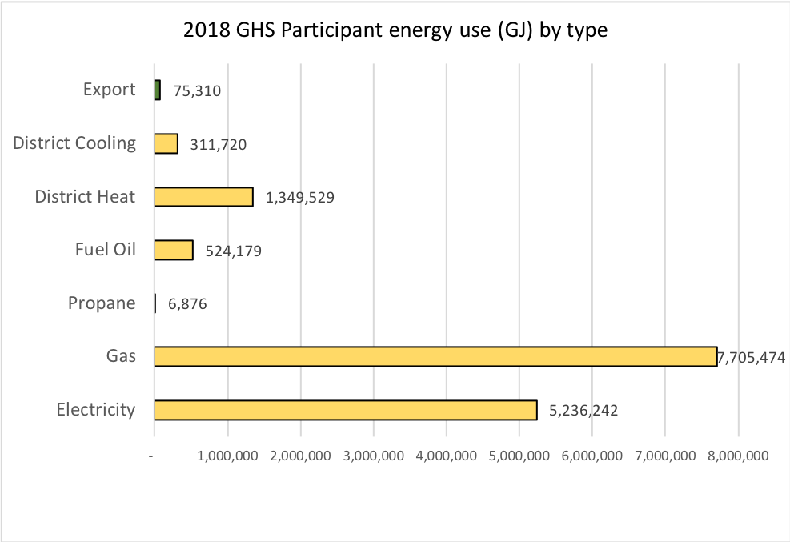
Canadian Coalition for Green Health Care, 2018
Gigajoules (GJ)
7, 705, 474
Figure 5: 2018 GHS participant energy use (GJ) by type

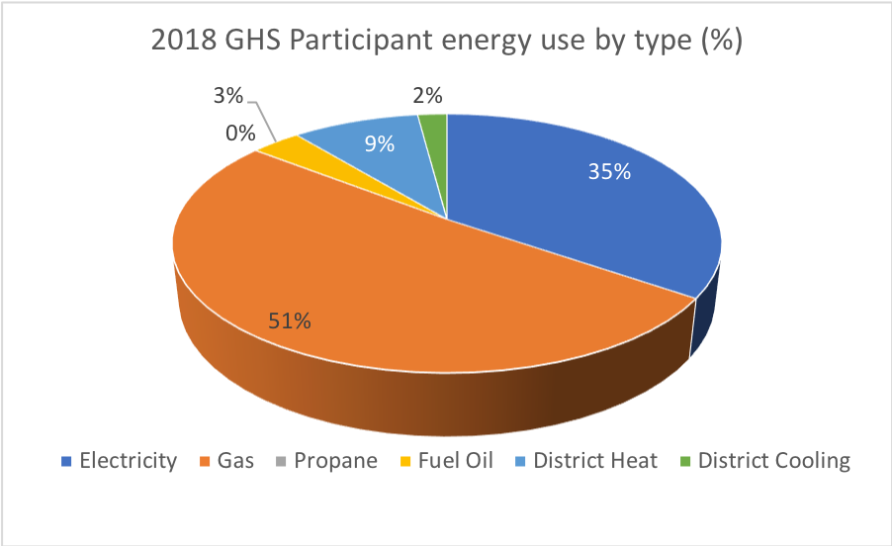
Canadian Coalition for Green Health Care, 2018
Figure 6: 2018 GHS participant energy use by type (%)

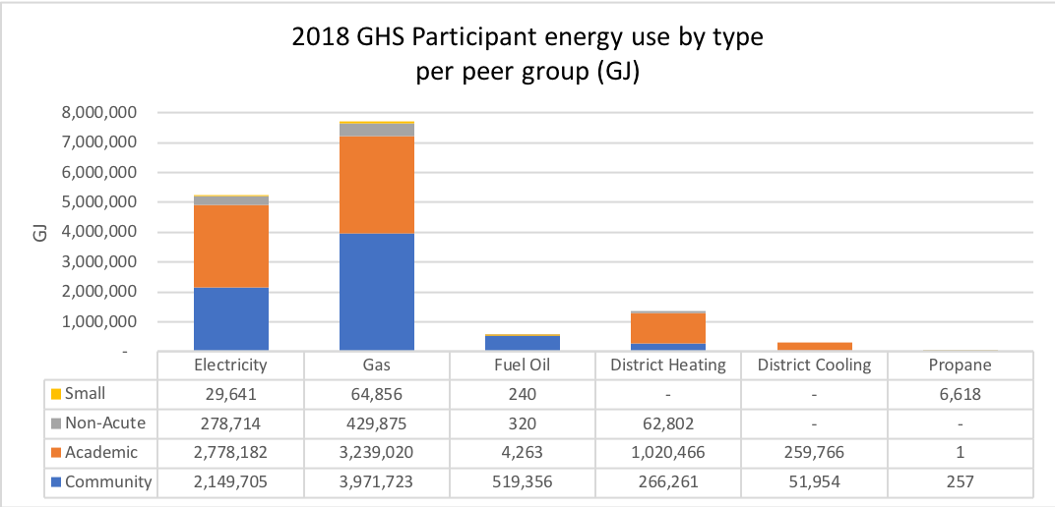
Canadian Coalition for Green Health Care, 2018

Figure 7: 2018 GHS participant energy use (GJ) by type per peer group

5.2.2 Energy Use Intensities
Energy use intensity (EUI) captures a building’s annual energy use as a function of its size. It is a measure that determines the building’s energy performance and is useful for benchmarking and setting targets. EUI’s are Environmental Performance Indicators (EPI) that hospitals can compare on an annual basis to see improvements.
Energy data reported by participants was converted to GJ so various energy types could be compiled and then divided by the reported floor area (m²) to calculate a final EUI (GJ/m²). The total average EUI across all hospitals was calculated to be 2.5 GJ/m²/year.
Figure 8 captures the average EUI by peer group (based on 2017 data). The highest EUI was found in Community hospitals, at 2.8 GJ/m²/year. Figure 9 shows the long-term EUI trends for each of the peer groups over the past five years. In all cases the EUI has shown a gradual decline over the five years, with the greatest drops in Small (17%) and Academic hospitals (16%).

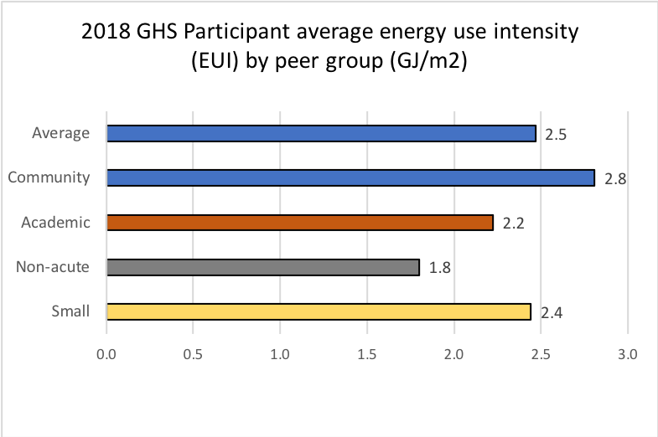
Canadian Coalition for Green Health Care, 2018
Energy Use Intensity (EUI) (GJ/m2)
Figure 8: 2018 GHS participant average energy use intensity (EUI) by peer group (GJ/m²)

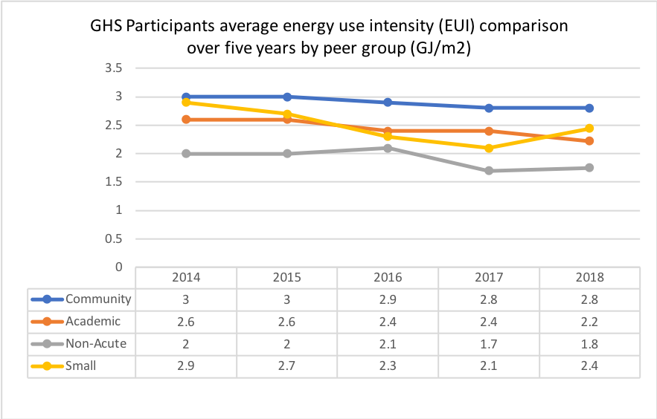
Canadian Coalition for Green Health Care, 2018
Figure 9: EUI comparisons over previous four years by peer group

5.2.3 Monitoring and Management
Participants identified how often they are tracking and reviewing their utility billing data. 83 out of 101 hospitals stated that they are tracking their data monthly. The second most frequent time frame for tracking data was identified as quarterly by 14 sites.

5.2.4 Energy Leadership, Initiatives and Innovations
According to Figure 10, one half of the hospitals report that they have budgets for staff engagement and outreach programming. 71 % of hospitals have energy conservation policies, and 67% stated having energy targets. Fewer hospitals responded to the question on energy action plans – of the 68 responders, 66 reported that they have energy action plans.

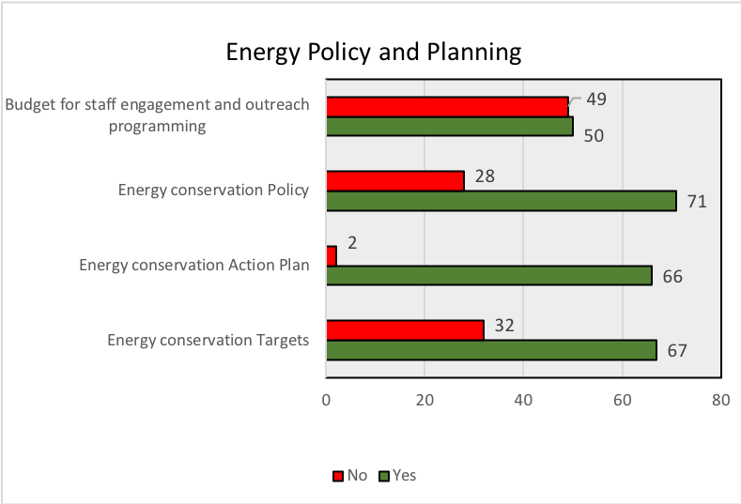
Canadian Coalition for Green Health Care, 2018
Responses

Figure 10: Number of 2018 GHS participants with energy conservation policies, targets and action plans.

District energy sources play a role at several sites through the following examples:
- 12 sites have stated that they received purchased steam from either utility companies or other partnering organisation powerplants. 6 sites referenced Enwave as a source of steam. Alternatively, several sites partnered with other hospitals or local universities to use energy plants to supply energy demands.
- A total of 7 sites explained their use of cogeneration sites to reach energy needs. It was calculated that capacity of cogen systems was over 100.57 MW between these 7 sites. Several sites use cogen systems for heating, cooling, humidification and sterilization. Three sites utilize cogeneration heat, which each drive 1000 Ton absorption chillers for cooling in the Summer time.

Examples of available resources which hospital staff have access to which can help them save energy include National Resources Canada’s (NRCan) online energy tools Portfolio Manager and RETScreen, and ENERGY STAR products, which can assist in identifying and meeting energy reduction targets. Figure 11 reveals that less than 20% of responding hospitals have used the Simple Savings Calculator and even fewer (13%) of hospitals report using NRCan’s RETScreen program. More responders (36%) use Portfolio Manager.

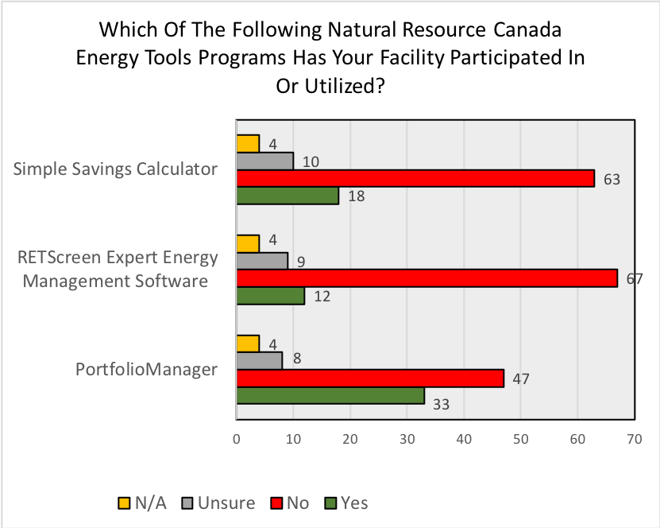
ENERGY STAR ®

67

Responses

Canadian Coalition for Green Health Care, 2018

Figure 11: Use of NRCan’s energy tools programs

There are numerous ways hospitals can incorporate energy conservation measures at their site, ranging from sustainable energy technologies to building automation. Below are some examples of what hospitals implemented in 2017. Examples of initiatives hospitals have taken related to energy management include:
- 4 hospital stated tracking their energy use of equipment information on intranet generating weekly reports of usage.
- 7 sites continued to provide e-Learning/education to staff on energy conservation.
- 2 sites incorporate ENERGY STAR products and other environmental considerations into account as part of their RFP process.
- 5 sites track their up-to-date energy information on internal databases.
- 4 sites are inputting data into a database that compares their data along with other members and normalizes weather. This database is considered to be very similar to Energy Star's Portfolio Manager program.
- Numerous sites upgraded lighting system to electronic T-8 technology
- One site reported that a combination of energy efficient HVAC technology and energy behaviour has reduced electricity consumption during the summer months significantly, and has allowed the site to decrease its peak demand by approximately 80% when necessary.
Some innovations which hospitals are undertaking also increase their use of energy. 24% of hospitals are reporting that they have set up electric vehicle charging systems for staff or visitors.

5.2.5 Renewable Energy
Across Canada in general, renewable electricity generation has increased 17% between 2010 and 2016, with solar and wind having the largest growth.

Within the health care sector, 60% of the participants reporting no renewable energy options were implemented at their facility, with a further 15% responding ‘Not Applicable’ as shown in Figure 12. Where renewable energy has been implemented, solar photovoltaics were the most popular at 9%. A total of 26 confirmed renewable energy projects were reported by participants. A lmost half of the respondents that currently do not have a renewable energy initiative reported they are considering renewable energy in the future, with a primary focus on solar-photovoltaics (Figure 13) . Other secondary renewable energy options under consideration include micro hydro, geothermal, and solar hot water systems . However, t here are still 46% of participants that reported either no renewable energy will be considered or that this option was not applicable.

Participants reported on some examples of current and future use of renewable energy
- 1 site has been considering CHP unit to displace electrical demand from grid.
- 1 site has a geothermal field that supplements the heating plant to drastically lower their fuel bills.
- 1 site is reviewing the viability of a waste heat recovery process.
- 2 sites incorporate Lake Water Cooling as a form of renewable energy
- 4 sites are currently offering biofuels as part of their back up fuel system
- Several sites have considered solar rooftop installations as an option for microgrid energy systems.
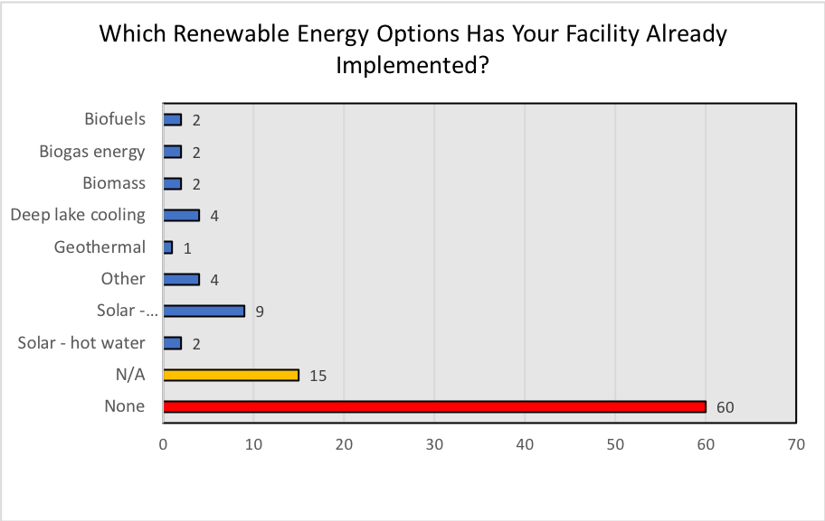
Photovoltaic
Canadian Coalition for Green Health Care, 2018
Responses
Figure 12 - Which renewable energy options has your facility already implemented?

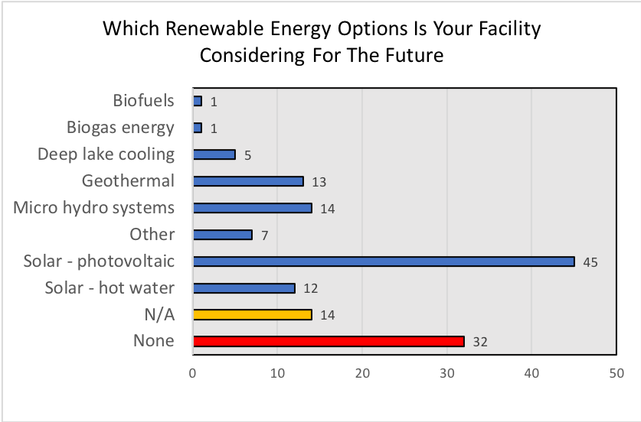
Canadian Coalition for Green Health Care, 2018
Responses
Figure 13 - Which renewable energy option is your facility considering in the future?

5.2.6 Building Energy Use CO₂ Equivalencies
Each participating hospital was provided with a Green Hospital Scorecard listing their building GHG emissions expresses as tonnes of CO_{2.} This total was calculated by incorporating hospital building total energy use and type of energy used. Figure 14 depicts the equivalent energy consumed by all the participants. In contrast, Figure 15depicts the required trees to sequester the sum total CO₂ from all 2018 GHS participating sites. The tool used to calculate these totals was the NRCan GHG calculator referenced below.

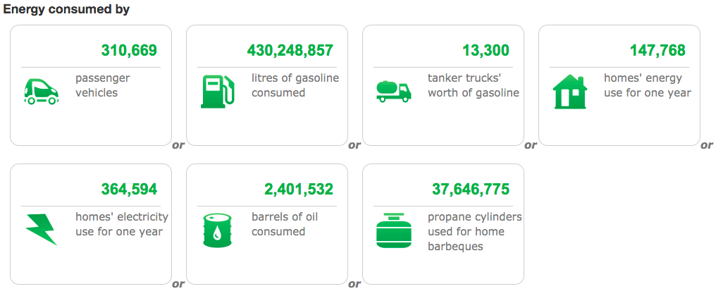
Figure 14: Building energy CO₂ equivalent for all participants
http://oee.nrcan.gc.ca/corporate/statistics/neud/dpa/calculator/ghg-calculator.cfm
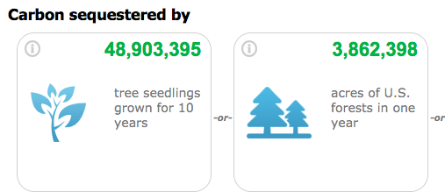
Figure 15: Predicted number of trees required to sequester total CO₂ equivalent
https://www.epa.gov/energy/greenhouse-gas-equivalencies-calculator

Water

6.1 Background
While Canada has seemingly an endless supply of potable water, Canadians are also one of the most wasteful of water resources in the world. Health care operations can be very water-intensive, and are often the largest water users in their communities.
The health sector faces unique challenges with respect to water conservation. In particular, infection control and prevention requirements make the implementation of some common routes for conserving water challenging or unfeasible.
Figure 16 provides an example of common uses of water in a hospital. The highest uses include plumbing fixtures (30%), evaporative cooling (25%) and the kitchen areas (17%), followed by irrigation (12%).
Examples of water conservation techniques for hospitals can be found in the GHG+H20 toolkit developed by the Canadian Coalition for Green Health Care.

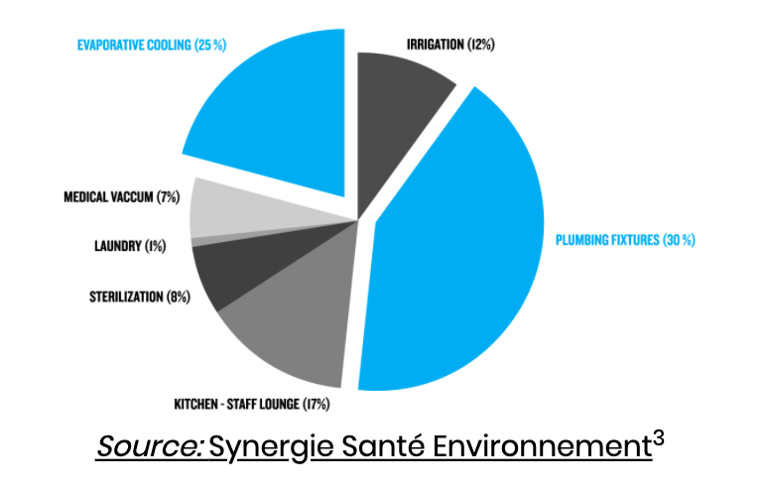

Figure 16: Examples of water uses in hospitals
For every unit of water used in a hospital, there is an energy requirement for pumping, treating and heating the water. Water conservation strategies can therefore directly improve environmental issues such as GHG emissions and water shortages, as well as economic issues such as expansion of water and wastewater infrastructures.

6.2 Results
Total water use by all participants in 2017 was 10, 697, 945 cubic metres of water across 101 hospitals, excluding any water volume used for grounds maintenance. Compared to the previous year, this was a decline of 2, 262, 567 cubic meters of water.

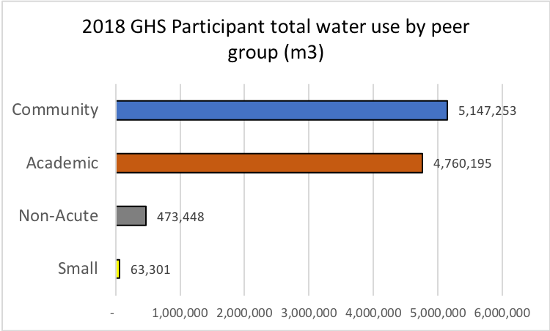
Canadian Coalition for Green Health Care, 2018

Figure 17: 2018 GHS participant total water use (m3) by per peer group

6.2.1 Water Use Intensity
Water Use Intensity (WUI) is expressed as the hospital’s annual water use relative to the total conditioned floor area. WUI is a measure that is used to determine the building’s water performance and is useful for benchmarking and setting targets. WUI’s are Environmental Performance Indicators that hospitals can compare on an annual basis to see improvements. Participant water data was converted to cubic metres and divided by the reported conditioned floor area (m²) to calculate a final WUI (m³/m²).

The total average WUI across all hospitals was calculated to be 1.8 m³/m²/year. Figure 18 highlights the average WUI’s for each peer group for 2018 GHS participants based on 2017 data. Community Hospitals had the highest WUI at 2.2 m³/m²/year while Non-Acute Hospitals had the lowest at 1.1 m³/m²/year. Figure 19 shows the average WUI over the last five years by peer group. All hospital peer groups reduced their water consumption about 10% over five years except the Small hospitals, which despite having a significant decline during the year 2016, showed an overall increase in water consumption.

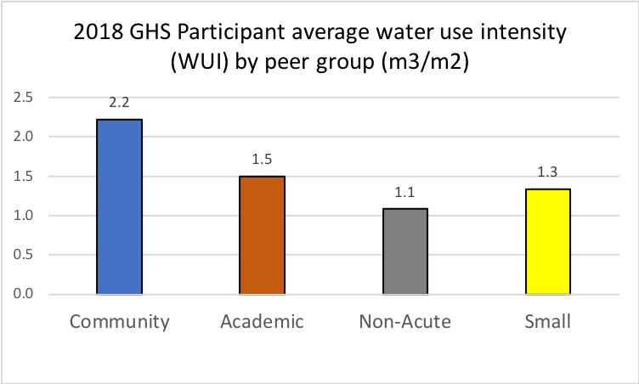
Canadian Coalition for Green Health Care, 2018
Figure 18: 2018 GHS participant average water use intensity by peer group

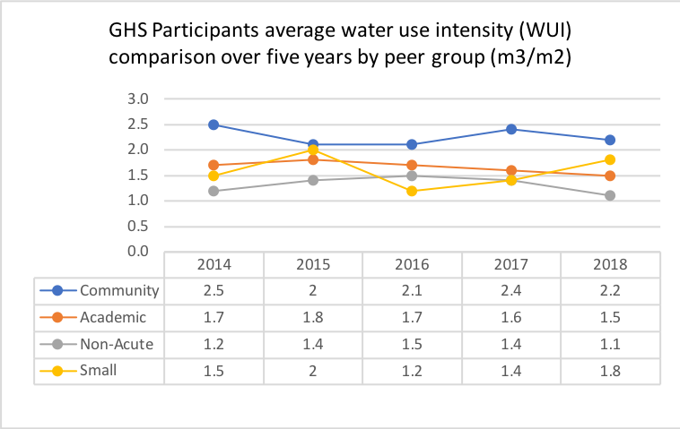
Canadian Coalition for Green Health Care, 2018
Figure 19: Average WUI per peer group over last five years
Canadian Coalition for Green Health Care, 2018

6.2.2 Water Conservation Leadership, Initiatives and Innovations
Figure 20 provides insight into water policy and planning activities at hospitals. Only 38% of the hospitals report that they have budgets for staff engagement and outreach programming. 53% of hospitals have water conservation policies, and 31% stated having water conservation targets. Fewer hospitals responded to the question on water action plans – of the 37 responders, 35 reported that they have water action plans.

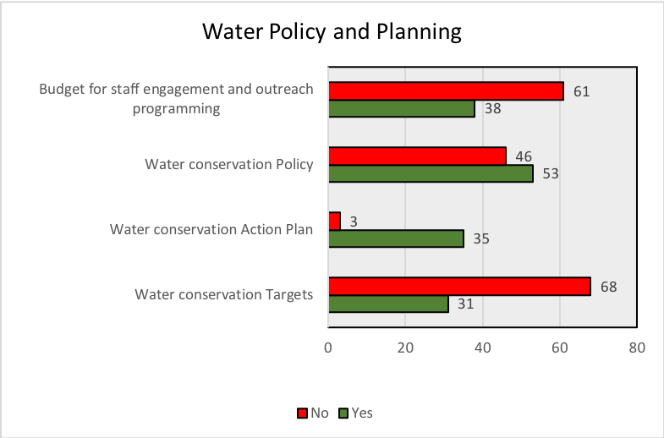
Canadian Coalition for Green Health Care, 2018
Responses
Figure 20: The number of participants with water conservation policies, targets and action plans in place during 2017.

Some examples of water conservation initiatives that participants have reported include:

- One site is equipped with water stations providing free drinking water for those that wish to fill a reusable water bottle.
- Another site developed a staff, patient and tenant education and awareness program related to water conservation
- Several sites regularly review of water consumption data to identify areas for potential improvement and discuss opportunities for savings
- Many sites attempt to incorporate low-flow water fixtures when purchasing for projects.

Waste

7.1 Background
In 2001 hospitals were responsible for 1% of total solid waste in Canada.
Hospitals use a significant quantity of single-use products, many of these are plastic, and are tasked with complying with infection control practices while providing excellent care. A conventional reduce, reuse and recycle approach is important, but the current model of resource use and waste management is still resulting in large quantities of waste disposed because the system has not been designed to optimize reduction, reuse and recycling.
Some forward-thinking health care facilities are starting to seek products for health services that result in less waste. At the same time some manufacturers are starting to provide products and services for the health care sector which have been redesigned to reduce the use of resources and be easily reused or recycled, while also creating safer products with lower toxicity. This shift from a linear approach to resource use (take-make-waste) towards a more circular model of managing wastes, is known as the Circular Economy.According to the Ellen MacArthur Foundation, this circular model is based on three principals: Design out waste and pollution; Keep products and materials in use; and Regenerate natural systems.
Current examples of waste reduction in the health care sector include use of digital documents instead of printing, and optimizing product inventories to reduce out-of-date products such as medicines. Examples of reuse include reusable sharps containers, sterilization and reuse of medical devices, linens and garments, and reusable wooden pallets. Recycling opportunities, which include packaging materials, paper products are not consistently available across our country and markets for materials are less developed for health care ‘wastes’ due to the concerns of contaminations related to hospital procedures as well as technical barriers to recycling. A circular model represents an opportunity to protect the environment by not only reducing but also phasing out wastes while reaping financial benefits.

This section provides information on the quantities of non-hazardous waste, recyclable materials, and biomedical waste. Non-hazardous materials are generally managed through landfill (or in some municipalities through their incinerators) and is the largest component of hospital waste. Recyclable materials include blue bin (which includes plastic, glass or metal/cans and paper), green bin (organic wastes), and other recyclable materials with specific diversion markets such as electronic wastes, and scrap metal. In some facilities recyclable materials can make up 40% or more of the total waste disposed.
Biomedical waste poses potential risks to public health and our environment and therefore must be segregated and managed accordingly. In Ontario, the definition of biomedical wastes is provided in the Environmental Protection Act as:
- human anatomical
- human blood waste,
- animal anatomical waste,
- animal blood waste,
- microbiology laboratory waste,
- sharps waste,
- cytotoxic waste,
- waste that has come into contact with human blood waste that is infected or suspected of being infected with any infectious substance (human), or
- a waste containing or derived from one or more wastes described in clauses (a) through (h), but does not include amongst other things,
- treated biomedical waste, or
- dialysis waste not saturated with blood or blood products that is tubing, filters, towels or disposable sheets.
Biomedical wastes are more expensive to dispose. Most facilities generate less than 10% of their total waste as biomedical wastes. If the percentage is higher, then the biomedical waste is contaminated with non-hazardous wastes or recyclable wastes and the facility will pay higher disposal costs. Training staff on proper segregation of wastes can reduce these disposal costs.

7.2 Results
Participants generated a total of 78, 011 Metric Tonnes (MT). This total was a decrease compared to the total of 86,892 MT from the previous year. The primary Environmental Performance Indicator (EPI) for waste is the Waste Diversion Rate. Collectively, all GHS participants diverted 19,024.86 MT from landfill. Compared to the previous year, the 2018 GHS saw a decrease of 7,175.84 MT total recyclables and other forms of non-disposable waste diverted from landfill (most likely related to 9 fewer participating hospitals). Total waste, non-hazardous and biomedical waste are shown by peer groups in Figures 21, 22, and 23 below, where Academic Hospitals always produced the highest amount.

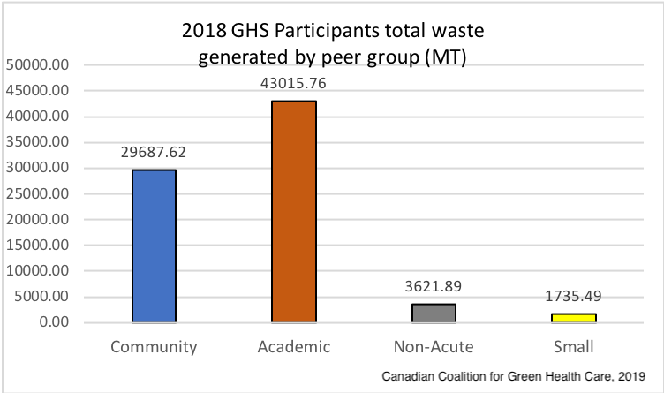
Metric tonnes (MT)
Figure 21: Total waste generated per peer group

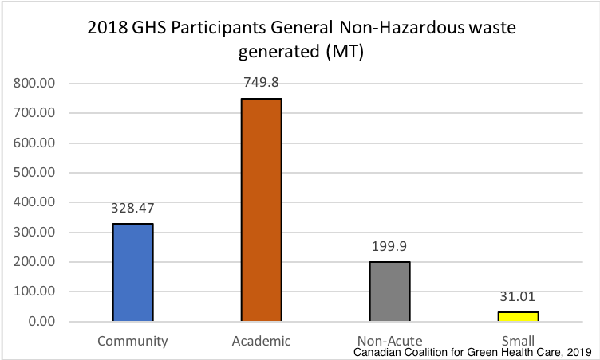
Metric tonnes (MT)
Figure 22 - Total non-hazardous waste generated by peer group

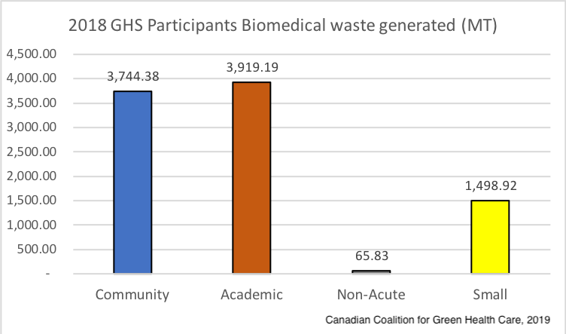
Metric tonnes (MT)
Figure 23 – Total biomedical waste generation by peer group

7.2.1 Waste Generation by Type
For all 2018 GHS participants the following waste quantity information and percentage of waste type is summarized below:

Waste Type | Total waste/material generated (MT) | Average percentage of total waste
General non-hazardous | 44,425 | 56%
Recyclable materials or other non-disposable wastes | 25,117 | 32%
Biomedical waste | 9, 228 | 12%
Total waste/materials | 78,770
Table 5 – Percentage and Total waste generated by all participating hospitals

The summary from Table 5 reveals that the average recycling rate by all participants is 31%. The types of recyclable materials and their quantities are provided in Figure 24. Shredded paper makes up the largest quantity of recyclable materials, followed by blue bin materials, cardboard, and green bin (organic or food wastes).

The average percentage of biomedical waste is 12%. This is higher than the expected 10% and therefore the data shows that there are facilities which are paying a greater cost for waste disposal than they would if they properly segregated materials and placed only biomedical waste in the biomedical waste containers.

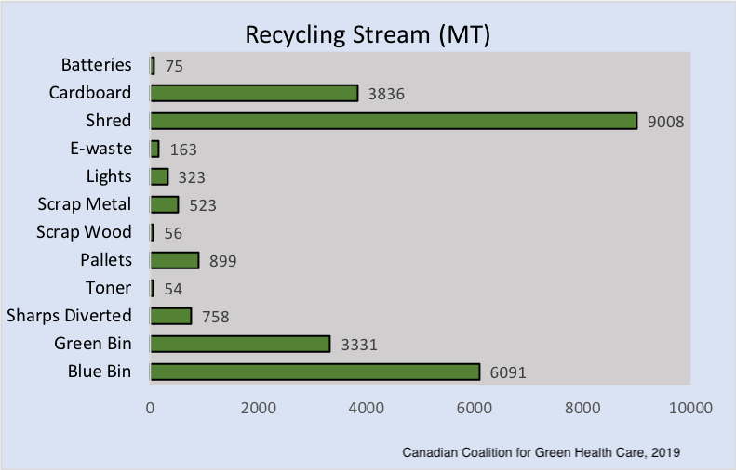
Shredded Paper
Figure 24: Participant total recycling and diversion by material type

7.2.2 Waste Use Intensity
A benchmarking comparison can be made between the total waste generated by hospitals for the 2018 GHS’s data collected (2017 data), based on similar peer groups. As the GHS participants were classified under four specific peer groups, a waste intensity comparison can be made by relating the waste for each peer group to the floor area, number of beds, inpatient days, and outpatient visits. With respect to waste management in hospitals, an EPI that is commonly used to analyse hospital waste generation is the comparison of weight of waster (MT) to number of beds. Table 6 shows that participants had a total average waste intensity of 3.317 MT/bed. A comparison can be made to the previous year’s 2017 GHS average waste intensity of 3.550 MT/bed, showing a decrease of 5.5%. In order to display this information more clearly, Table 6 outlines the average waste KPI’s for each peer group. The average waste intensity is lowest in Non-Acute Hospitals and greatest in Smaller Hospitals. The average waste per bed is lowest in Non-Acute Hospitals and greatest in Small Hospitals. The average waste per in-patient days is greatest in Academic Hospitals and the average waste per outpatient visits in greatest in Community and Academic Hospitals.

Peer Group | Average Waste Intensity (MT/m2) | Average Waste MT/ Bed | Average Waste MT/ Inpatient days | Average Waste MT/ Outpatient Visits
Community | 0.012 | 2.926 | 0.011 | 0.005
Academic | 0.012 | 3.557 | 0.049 | 0.005
Non-Acute | 0.008 | 1.800 | 0.006 | 0.008
Small | 0.045 | 7.762 | 0.006 | 0.002

All | 0.014 | 3.317 | 0.022 | 0.005
Table 6: Average waste intensity by KPIs and peer group

7.2.3 Waste Management Leadership, Initiatives and Innovations
The purpose of a waste management policy is to clearly define the goals and objectives for hospitals with respect to their waste reduction, reuse and recycling. Hospitals with an appointed committee of waste management champions, dedicated to green initiatives (i.e. Green Team) can provide leadership in creating waste management policies. Each hospital could benefit from having an Environmental Management System (EMS) that starts off with developing policies and procedures so that hospital staff can follow them as a template for waste management.

Figure 25 displays the percent of participants with waste management policies, targets and action plans in place during 2017. Only 41% of the hospitals report that they have budgets for staff engagement and outreach programming. 66% of hospitals have waste management policies, and 54% stated having waste management targets. Fewer hospitals responded to the question on waste action plans – of the 55 responders, 53 reported that they have waste action plans. In some provinces, like Ontario, waste reduction action plans are mandatory for a certain size of hospitals.

Participants provided a range in identified targets to reduce waste. These ranged from reducing use of paper through prioritising electronic communication, to partnering with external organisations to fully recycle electronics, to complete elimination and phasing out of harmful chemicals such as mercury.

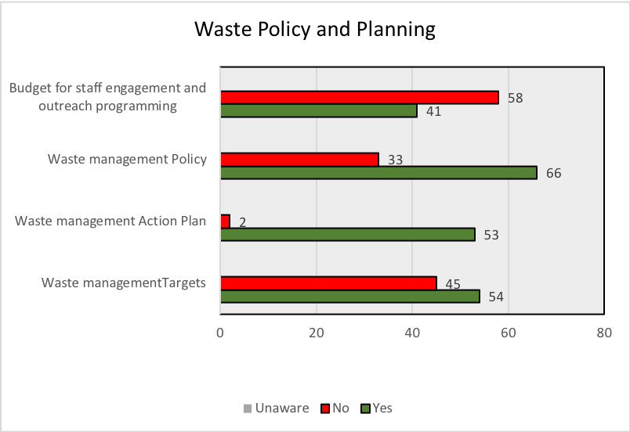
Canadian Coalition for Green Health Care, 2018
Responses
Figure 25: Participants with waste policy and planning initiatives

Pollution Prevention

8.1 Background
Pollution Prevention is a concept that focuses on selecting less toxic and more environmentally preferred materials for use within the hospital, and considering the impacts of building construction on the environment and within the hospital. In the Green Hospital Scorecard, supporting a "Do no harm" philosophy in health care recognises a need for health care providers to reduce and phase out materials that are pose a threat to human health and the environment.
Pollution Prevention consists of:
- Environmentally preferable purchasing, which aims to reduce an organization’s environmental impact upstream through the purchase of products which have environmentally preferred qualities
- Toxins management, which aims to reduce the downstream impacts caused by managing materials, products and services within hospital that are considered toxic to human health and environment, as well as the appropriate disposal of special and toxic wastes.
- Sustainable construction/renovation practices, which aim to reduce the environmental impact of hospital sites through the selection and use of sustainable construction and renovation materials and engagement of sustainable construction/renovation practices.

8.2 Results
Figure 26 reveals that 41% of participants have a pollution prevention policy in place.

Figure 27 asks about Environmental Purchasing policies, where only 24 hospitals report having an Environmentally Preferable Purchasing Action Plan, and 22% have Environmental Preferable Purchasing Targets.

The following is an adaptation of one site’s Environmentally Preferable Purchasing criteria when selecting products and services:
- Assess the environmental impact of the product's life cycle (raw material acquisition, manufacturing, packaging, distribution, use and disposal);
- The reusability of a product or supply (Circular Economy);
- Product packaging and recyclability;
- Complying and ahead of legislative, regulatory, and other requirements
- The toxic ingredients of a product (priority given to those with few or no toxic ingredients, especially Mercury and PVC) and;
- Transportation involved with manufacturing and receiving products
- Energy efficiency of the product.

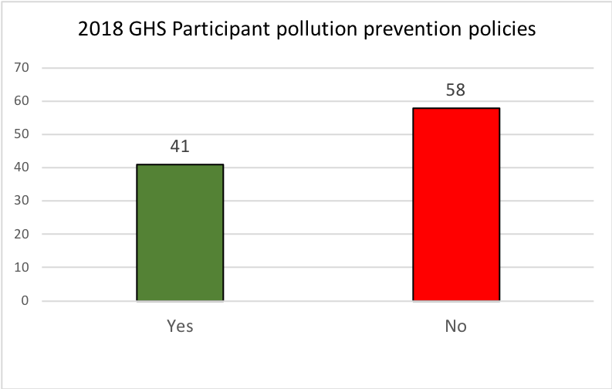
Canadian Coalition for Green Health Care, 2018
Responses
Figure 26: Percent of participants with pollution prevention policies

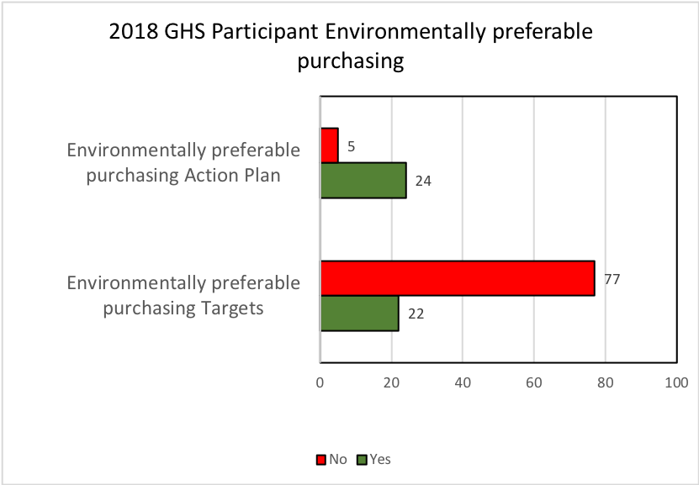
Figure 27: Participant targets and action plans for environmentally preferable purchasing
Canadian Coalition for Green Health Care, 2018
Responses

8.2.1 Toxins Management Initiatives
With respect to Toxics Management, Figure 28 provides that 56% have Toxics Management Policies, while 28% have Targets. Fewer responses were provided for the question on Action Plans, and of the 33 responses, 30 participants indicated that they have a Toxics Management Action Plan.

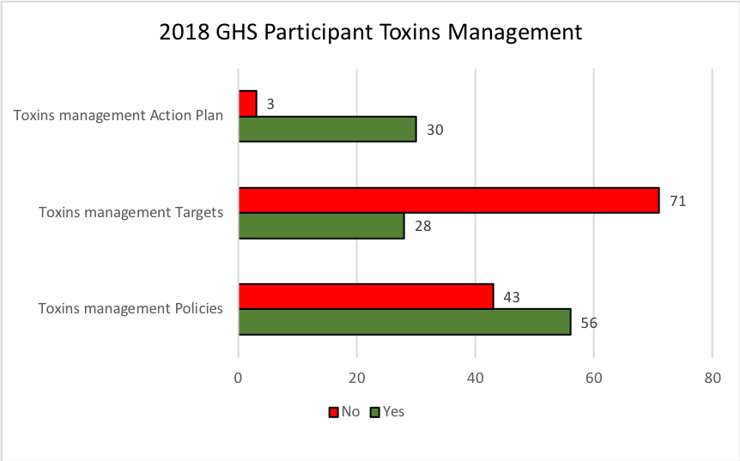
Canadian Coalition for Green Health Care, 2018
Responses
Figure 28: Participant toxins management policies, targets and actions

Examples of toxics reduction initiatives reported by participants include:
- One site diverts 90 KG of anesthetic gas annually.
- Two sites have an inventory of all chemicals used and disposed and conducting risk assessments. While, Mercury and Latex are also limited and banned in most areas of these sites.
- Four sites initiated an anesthetic gas technology pilot project

8.2.2 Sustainable Construction/ Renovation Initiatives
With respect to sustainable construction and renovations policies, targets and actions, 46% of participants reported having policies in place, and 34% having targets. Fewer responses were provided for the question on Action Plans, and of the 40 responses, 32 participants indicated that they have a Sustainable Construction and Renovation Action Plan.

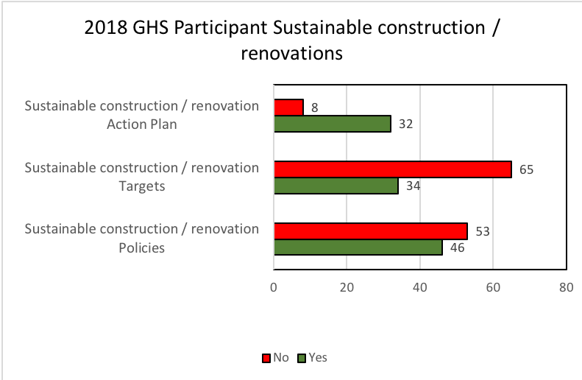
Canadian Coalition for Green Health Care, 2018
Responses
Figure 29: Participant sustainable construction and renovations policies, targets and actions

Examples of sustainable construction and renovations initiatives reported by participants include:
- Four hospitals became LEED certified, generating substantial energy savings through implementing upgrades to lighting, heating, along with diverting construction waste from landfill.
- One site is LEED Certified Gold, which requires a preferential procurement of materials with recycled content, products made from renewable resources, energy efficient lighting and mechanical systems, low-flow water fixtures.
- One hospital has integrated drought free grass that does not need to have a watering system in place.

8.2.3 Other Pollution Prevention Initiatives
Examples of other Pollution Prevention initiatives reported by participants include:
- One site has reduced through energy saving projects total GHG emissions of 4,872,825.64 kg of CO2, 24,213 kg of SO2, 78 kg of CH4 and 74 kg of N2O on average per year.
- Two sites test for toxins through affluent sample analyzing.
- One hospital runs two buses to transport staff and patients between all three sites.
- One hospital’s security uses hybrid vehicles, and ground patrols on bike.

Corporate Leadership, Planning and Management

9.1 Background
Corporate leadership, planning and management, measure an organization’s commitment to a culture of environmental sustainability and integration of green objectives into corporate planning and regular business. The presence or absence of a policy justifies a corporate commitment, while it may lack a holistic view on the level of commitment and engagement from hospital staff. Corporate commitment focuses on the following three areas:
- Leadership: A measure of corporate commitment to environmental sustainability as gauged by the presence of formalized organization-wide support and outreach for green initiatives;
- Planning: A measure of a hospital's progress in environmental planning and target-setting with action plans; and
- Monitoring & Management: A measure of a hospital's commitment to tracking and monitoring regular resource expenditures.

9.2 Results

9.2.1 Corporate Leadership
The 2018 GHS measures corporate leadership qualitatively, through the presence of formal commitments, corporate-level programs, and policies that support green initiatives within hospitals. A total of 101 participants provided responses to these questions for policies, targets and action plans which were in place during the 2017 data collection period.

Corporate commitment to green initiatives
- 78 GHS participating hospitals have a corporately recognized environmental mandate or commitment;
- 79 GHS participants have an executive champion accountable for the overall hospital environmental strategy;
- 61 GHS participants have a full-time employee dedicated to environmental initiatives; and
- 63 participating sites have a green team (shown in Figure 30).

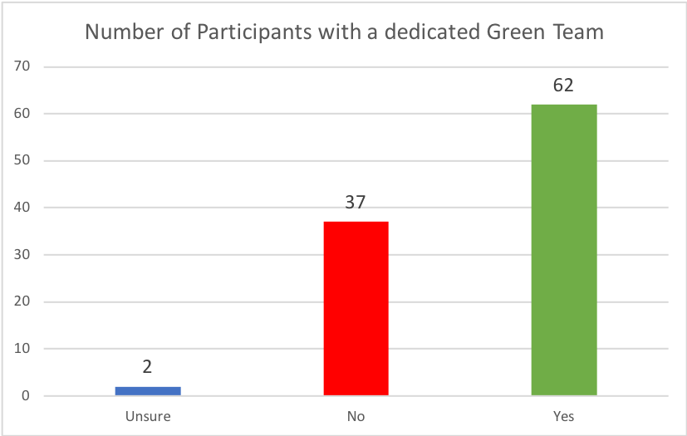
Figure 30: Participating sites with green teams

9.2.2 Programming

The following programming areas were revealed in the data analysis:
- Participants were asked if they offer staff engagement and outreach programming for the following areas:

Staff engagement and outreach programming
- 70 participants have energy conservation
- 76 participants stated that they have waste management
- 53 participants have water conservation
- 66 respondents in green events such as Earth Day

- Participants were asked if they allocate a budget for staff and engagement for the follow areas:
Budget for staff engagement and outreach programming
- 51 in green events such as Earth Day
- 50 participants in energy conservation
- 41 participants in water conservation
- 38 participants in waste management

9.2.3 Planning
A hospital’s corporate commitment to environmental performance improvements include creating policies, setting clearly defined targets and having an action plan in place stating how that target will be achieved. Through the 2018 GHS, 101 participants provided responses to questions for policies, targets and action plans which were in place during the 2017 data collection period for energy, water and waste.

9.2.4 Monitoring and Management
Participants identified how often they are tracking and reviewing their utility billing data. 83 out of 101 hospitals stated that they are tracking their data monthly. The second most frequent time frame for tracking data was identified as quarterly by 14 sites.

Transportation

10.1 Background
This newly added category focuses on the policies, and infrastructure to support active and clean transportation. According to the Government of Canada, active transportation is using your own power to get from one place to another and includes walking, jogging and biking, whereas, clean transportation includes public transit, car-polling, shuttles and low-emission vehicles. A low-emission vehicle is a motor vehicle that emits relatively low levels of motor vehicle emissions. Zero emission vehicles (ZEVs) are those vehicles that can operate without tailpipe emissions and include battery electric, plug-in hybrid electric and hydrogen fuel cell electric vehicles.

The Canadian transportation sector is responsible for the second largest source of greenhouse gas (GHG) emissions in Canada with light duty vehicle (LDV) emissions accounting for approximately 50% of Canada's transportation-related GHG emissions, and 12% of the country's total emissions. In Canada, sales of new ZEV passenger vehicles are still relatively low but increasing steadily. In the first quarter of 2019, 3% of LDV sales were ZEVs, up from 2% in 2018. The Government of Canada is encouraging the electrification of passenger transportation through ambitious federal targets for ZEVs that are set at 10% of LDV sales per year by 2025, 30% by 2030 and 100% by 2040.

For additional information see the Coalition’s website on the zero emissions vehicle project. https://greenhealthcare.ca/zev/

10.2 Results
42% of participants report that they have a program in place to promote alternative transportation to replace single use vehicles.

10.2.1 Zero Emission Vehicles
With the expected increase in demand for electric vehicles, hospitals have an opportunity to support low emission technology. A quarter of respondents have been taking the lead with 24% of facilities reporting that they have electric vehicle charging stations and 27% have preferred parking for low emissions vehicles (Figure 31). None of the respondents report that their hospital fleets include low emissions vehicles.

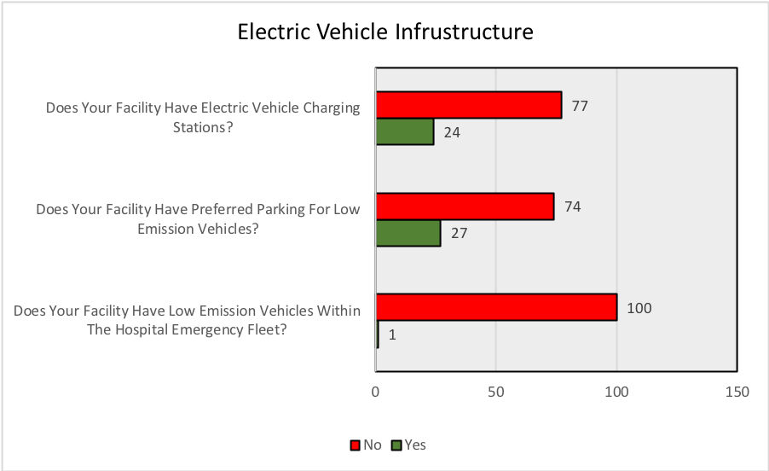
Canadian Coalition for Green Health Care, 2018
Responses
Figure 31 – Electric Vehicle Infrastructure

10.2.2 Telemedicine
According to the Ontario Telemedicine Network, telemedicine (also known as virtual care) uses telecommunications technology to provide clinical health care at a distance. This helps improve access to medical services that often would not be available consistently in distant rural communities. The aim of these question is to understand how Canadian health care facilities are adopting telemedicine, along with any perceived barriers. According to Figure 32, 78% GHS participants reported that their site incorporates telemedicine into the delivery of health services.

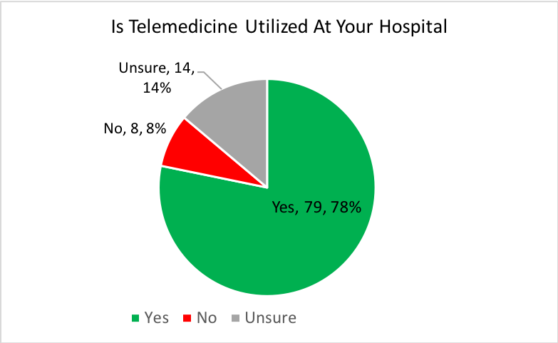
Canadian Coalition for Green Health Care, 2018
101 Respondents
Figure 32: Telemedicine utilisation at participant sites

Other active and clean transportation Initiatives reported by participants include:
- One site initiated a partnership with another local hospital to create a “Step Challenge competition” - to encourage all staff to walk more and if possible drive less.
- Several sites are members of the Smart Commute Program in the Greater Toronto Aea, which promotes active and sustainable transportation modes. This includes participation in a carpooling month, and Smart Commute week.
- 570 staff were enrolled in one site’s bus subsidy program, representing about 14% of the all staff. This program subsidized round-trip bus travel by approximately 51% when used 5 days per week.
- Three sites offered shuttle bus services, which provided over 36,000 trips between their various sites.
- Six sites listed offering prioritized parking spaces for carpooling.

Food

This years’ Green Hospital Scorecard confirmed that health care facilities have begun to adopt policies and practices to support a healthy food system. This is a system that includes environmental sustainability, improves nutritional quality, supports a shift to low-carbon foods, builds healthy communities, and supports culturally appropriate and sustainable foods. The Nourish Program was developed with the belief that food is fundamental to patient, community and planetary health and well-being, and is one of the health care targeted healthy and sustainable food initiatives in Canada.

11.1 Results
This section of the GHS will demonstrate how hospitals policies and programming are attempting to support a healthy food system. While acting as a significant purchaser of food products, health care has the opportunity to shape sustainable food systems.

11.1.1 Food Policies
While hospitals had high levels of food waste policies along with diet and educational programming, only a third had formalized healthy food policies (Figure 33).
Also according to Figure 33, over half (55%) of 2018 GHS participants purchase local food for their site. 40% of the sites have local or sustainable purchasing criteria within their contracts or RFPs.

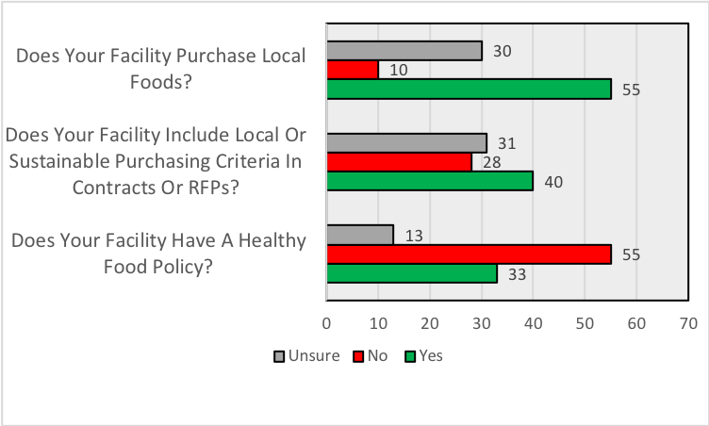
Canadian Coalition for Green Health Care, 2018
Respondents
Figure 33: Participant sustainable and healthy food purchasing initiatives

11.2 Food Initiatives
Hospitals provided insights into their growing number of initiatives dedicated to food systems. The 2018 survey involved introducing questions around which food services were offered within hospital sites. According to Figure 34, 70% of respondents stated that their site offers diet and nutrition education programming, 39% of sites are offering room service, 18% have onsite farmers markets, and 11% have onsite food gardens. Of the program types with the least participation, 4% of the sites are offering the following: patient malnutrition task force, antimicrobial stewardship programs, community shared agriculture programs and traditional food programs for indigenous populations. 14% of the sites did not engage in any of the eight food initiatives listed in the chart.
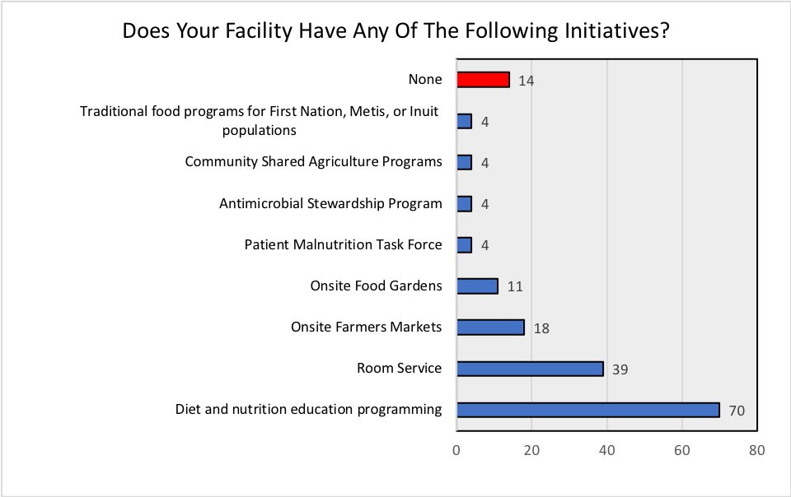
Canadian Coalition for Green Health Care, 2018
Responses

Figure 34: Hospital healthy and sustainable food system initiatives

Along with policies, and initiatives, survey respondents were also asked about perceived barriers towards replacing animal-based products with plant-based products, which can also contribute to reduction of GHGs.

Figure 35, which had a low response rate (36%) revealed a perception that lack of financing was the greatest barrier towards replacing meat with plant-based products.

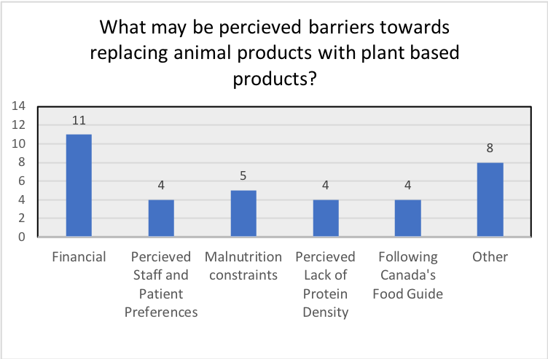
Canadian Coalition for Green Health Care, 2018
Figure 35: Perceived barriers towards replacing animal products with plant based products

One third (33%) of respondents report that they do not have a food waste management program (Figure 36).

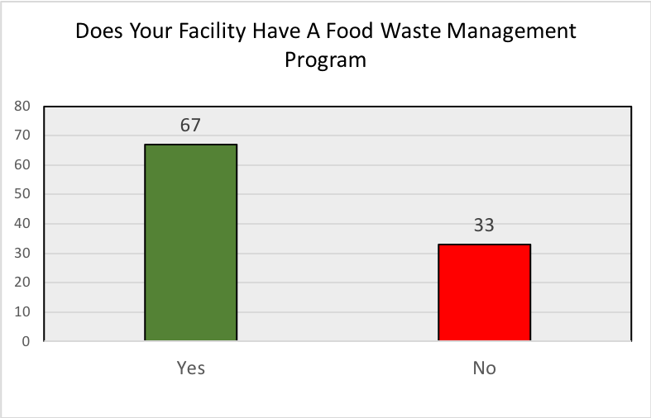
Canadian Coalition for Green Health Care, 2018
Figure 36: Hospital food waste management programs

Climate Change

Climate-related events are already impacting hospitals in Canada. The frequency and magnitude of severe weather events such as extreme heat, cold, rain, ice, snow, winds and storms have increased, as forecast by the Intergovernmental Panel on Climate Change (IPCC).Increasing, global temperatures will also result in rising sea levels, melting permafrost and droughts and dry conditions which will spur on wildfires. To help reduce the catastrophic effaces of climate change, Canada has committed to an economy-wide target for GHG emissions reductions of 30% relative to 2005 levels by 2030.

Canada’s health care sector is a significant contributor to GHGs. A 2018 study reported that GHGs emitted from Canada’s health care sector life-cycle, which includes direct emissions from hospital buildings and indirect emissions from their supply chain, represented an estimated 4.6% of the total national GHG emissions in 2015 or 0.0330 Gigatonnes (GT) CO2 eq. GHG emissions in the health sector are increasing at double the rate of the national average; 10% compared to 5% between the years 2009 to 2015. Given its increasing annual contribution to Canada’s total GHG output, targeted support programs to reduce emissions in the health sector could play an important role in national climate change mitigation efforts. Eckelman et al. also report that the most significant GHG emissions in the health sector are from: prescribed and non-prescribed pharmaceuticals (25%); hospitals (24%); and physician services (13%).

Canada’s health care sector GHG emission sources have been estimated from the three scopes of GHG analysis which are provided below, along with examples below.

- Scope 1: 26%
  - Stationary, on-site combustion for the generation of electricity, heat or steam,
  - Combustion of fuels in company owned/controlled vehicles,
  - Anaesthetic gases and nitrous oxide,
  - Other fugitive emissions e.g. air conditioning and fire suppression chemicals
- Scope 2: 13%
  - Electricity purchased by the health care organisation
  - Indirect emissions associated with electricity transmission and distribution losses
- Scope 3: 61%
  - Waste disposal
  - Water supply and disposal
  - Staff travel (business)
  - Staff travel (commuting)
  - Patient/visitor travel
  - Supply chain (pharmaceuticals)
  - Supply chain (medical devices)
  - Supply chain (food)
  - Supply chain (construction)
  - Supply chain (other - general)
This is further illustrated in Figure 37, which shows that most of the GHG emissions from the health sector are fom Scope 3 – The health system supply chain.

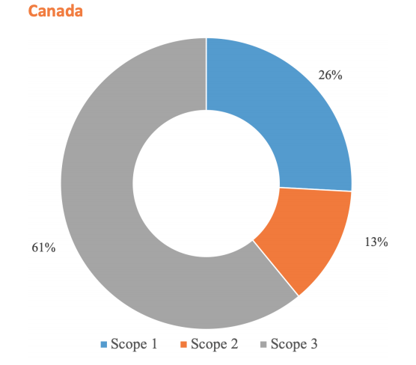
Figure 37: Canada’s health care climate footprint (HCWH 2019 report)

Hospitals can take GHG mitigation actions and reduce their emissions, through use of clean technology, undertaking energy efficiency, and changes in behaviour as well as addressing GHGs from their supply chain. Hospitals can also become more resilient and adapt to the increased prevalence of extreme climate related events while at the same time becoming more sustainable. For additional information see ‘Taking Action on Climate Change at Health Facilities’.

12.1 Results

12.1.1 Recognition of climate change as an issue of concern
The first step to action at a health care facility is recognition of climate-related impacts as an issue of concern by senior management. Figure 38 reveals that most participant sites have some recognition of climate change as an issue of concern. 54% of participants reported that their facility has assigned at least one person with some climate change responsibility, 8% have included climate change risk in their facility Strategic Plan, and in specific policies. 30% of participants have not recognized climate change as an issue of concern, and 10% of respondents did not know.

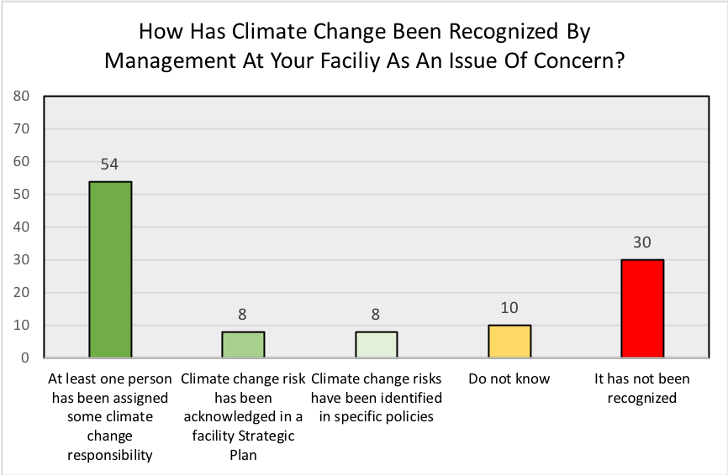
Canadian Coalition for Green Health Care, 2018
Figure 38: Number of hospitals with management recognizing climate change as an issue of concern

12.2.1 Climate-related events affecting hospitals
Figure 39 provides insights into what kinds of climate-related events the hospitals have experienced. Many participants reported more than one type of event. The most common events were extreme heat, including extended periods of heat, reported by almost half of the participants (49%); 42% report experiencing extreme cold; and 36% report experience flooding. Only 36% of participants reported no climate-related events.

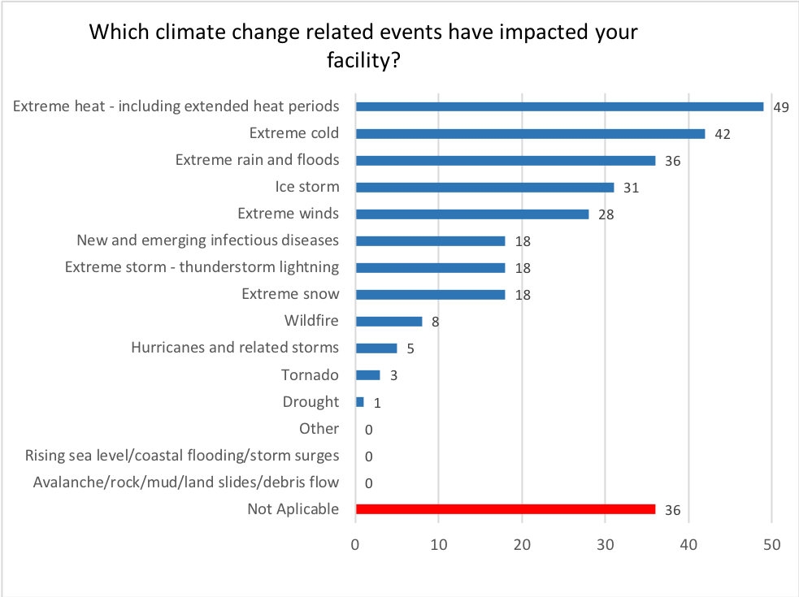
Canadian Coalition for Green Health Care, 2018
Responses
Figure 39: Climate change-related events impacting hospitals

12.2.2 Climate-related impacts on hospitals
Figure 40 provides insights into how the hospitals have been impacted by climate-related events, with many participants reporting experiencing more than one type shock to their facilities. Infrastructure damage was reported by the greatest number of participants (44%); 30% report that patients experienced reduced access to hospital services and 22% of participating hospitals experienced reduced access to supplies and services as a result of climate-related events. 30% report no impacts to their facilities from climate-related events.

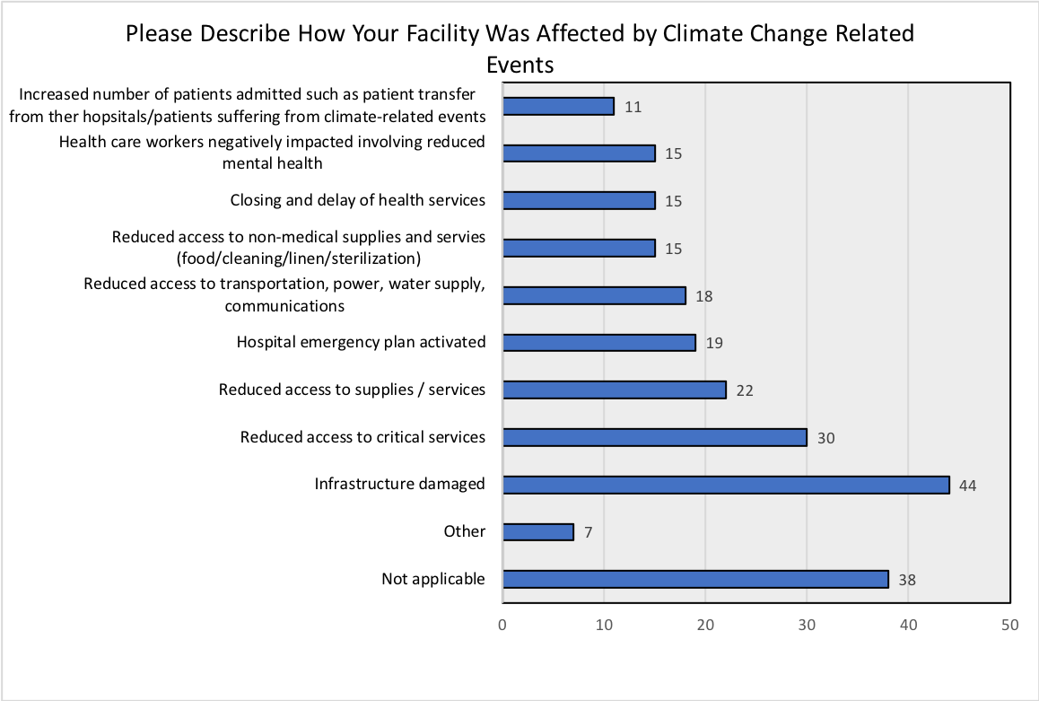
Canadian Coalition for Green Health Care, 2018
Responses
Figure 40: How a facility was affected by climate change-related events

12.2.3 Resiliency and Vulnerability Assessments
Survey respondents were asked if they had completed a resilience assessment or a vulnerability assessment. Of the health care facility staff responders (99 responders) 9% reported having completed resilience assessments while only 4% have completed vulnerability assessments. The majority of those that have reported completing a resilience assessment were participants in the Coalition’s Climate Change Resilience Mentoring program.

Energy Behavior

13.1 Background
Accounting for human behaviour patterns in energy management in addition to technology can potentially result in greater energy savings and persist for longer periods of time than if the human element is ignored. While human behaviour has been well studied in projects directed at the residential sector, not as much is known about how the industrial, commercial and institutional sectors can benefit by including a human focus to energy management. In the 2018 GHS survey, questions related to energy behaviour were included to better understand, knowledge of key actors, initiatives, norms and goals around energy behaviour in hospitals. By incorporating the principles of energy behaviour, organizations can incentivize conscious energy use by staff and patients and operationalize savings through planning, supporting, investing in, and implementing energy savings projects.

13.2 Results

13.2.1 Energy Behaviour Awareness
Figure 41 shows that a majority of participants became aware of energy behaviour through conferences (72%), Webinars (64%) and workshops (63%). There were smaller number of participants that have learned through formalized training, and a small portion that have become aware through other means.

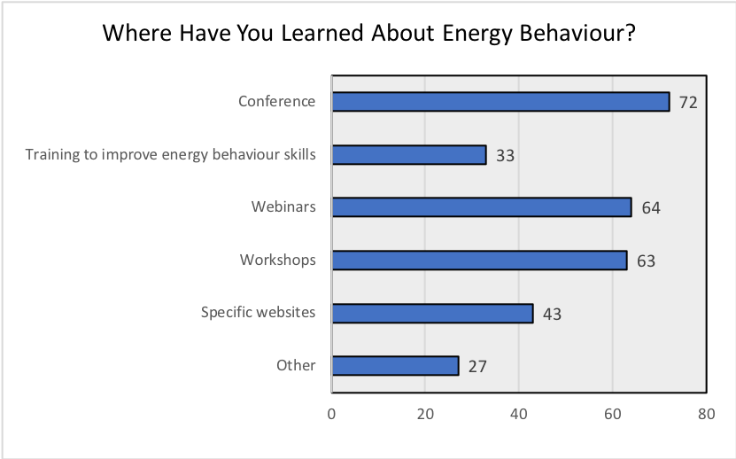
Canadian Coalition for Green Health Care, 2018
Responses
Figure 41: Participant awareness of Energy Behaviour

13.2.2 Energy Behaviour Policy
A part of implementing energy behaviour involves leadership and having a dedicated full-time-equivalent (FTE), or energy champion to support staff. 81% of the responders reported that their facilities have a dedicated energy champion and 61% of staff feel they will not be penalized for taking energy saving actions. However, fewer respondents said that they have enough time to practice new energy saving actions (42%) and only 31% indicated that there were enough people thinking about energy saving actions at work (Figure 42).

In addition, the following aspects were also reported:
- 47% of participants report that energy consumption data is visible to staff who may require it to plan new energy saving measures
- 67% of participants report that frontline staff participate in energy decision making
- 42% of participants reported that energy efficiency is applied consistently across the organisation
- 93% of participants reported that complex energy saving projects have been considered
- 86% of participants reported that complex energy saving projects have been approved
- 47% of participants report that energy savings are exceeding expectations
- Over half of all participants stated energy behaviour programs or projects which included an evaluation

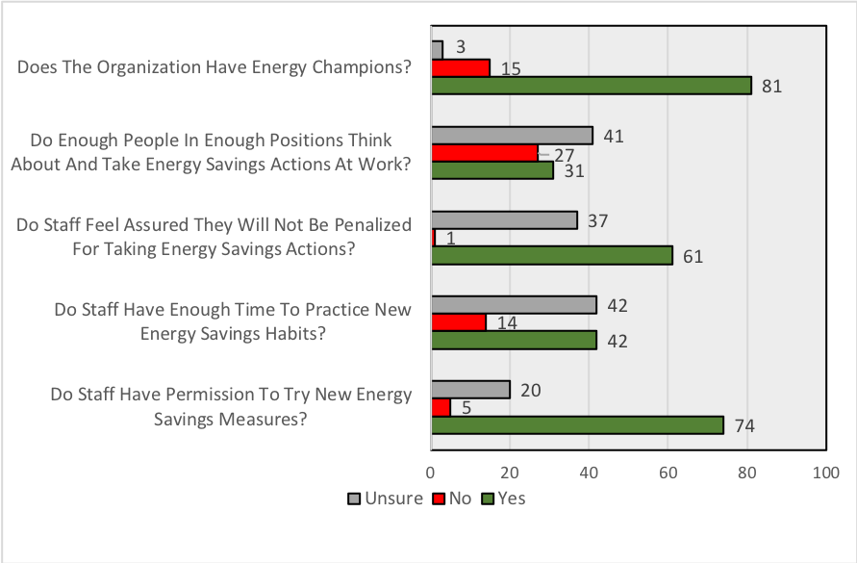
Canadian Coalition for Green Health Care, 2018
Responses
Figure 42: Participant energy behaviour awareness

13.2.3 Self-ranking of Energy Behaviour Integration at Facility
Relying on self-ranking, GHS participants stated how they viewed integration of energy behaviour within their particular site. According to Figure 43, one-third of hospital sites believe that they have exemplary energy behaviour initiatives (self-ranking as high, or a 6 or 7) and have developed system-wide strategies to conserve energy. Five sites self-ranked as very high, or 7 out of 7. However, of the hospitals which self-ranked themselves as 7 out of 7, all had provided at least one inconsistent response on the other energy behaviour survey questions, indicating that they acknowledged underperformance in some areas. This fact points to the possibility that some responders were exaggerating their energy behaviour performance, while others may have underreported their self-assessed ranking.

While no hospitals self-ranked at 1 out of 7, almost one half (or 48 hospital sites) self-ranked as 2, 3 or 4 out of 7, indicating there is room for significant improvement in the hospital sector to incorporate energy behaviour principles in support of energy performance.

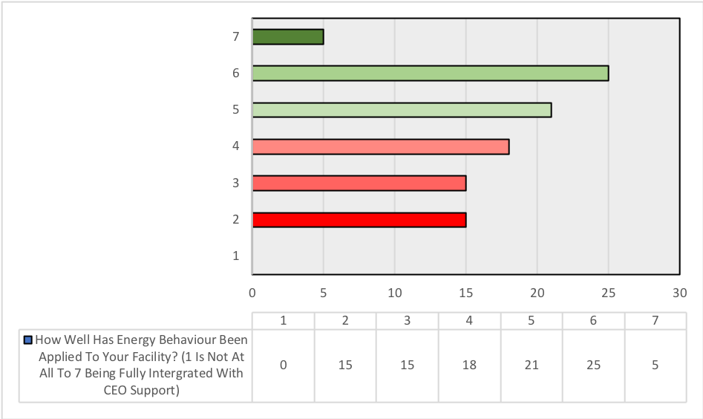
Figure 43: Applying energy behaviour principles at facility: self-ranking within 2018 GHS participating sites
13.2.4 Energy Behaviour Award
This was the first year for the Ontario Green Health Care Energy Behaviour Award, sponsored by Save on Energy. Winning hospitals were selected by analyzing the responses to the survey questions, which included hospital engagement and knowledge around energy behaviour. London Health Sciences Centre was the inaugural winner through their advanced knowledge and integration of energy behaviour into their facility. Two hospitals shared Honourable Mention: St. Joseph’s Healthcare London, and University Health Network in Toronto.

Of note is that all three hospital sites are high energy performers as well (Section 5). This year, University Health Network won the overall highest score and the energy award for the Academic Hospital category, and St. Joseph’s Healthcare London won the energy and water awards for the non-acute care category. London Health Sciences Centre’s energy behaviour program has persisted for approximately 17 years, and the University Health Network’s program has been in place for around 10 years, showing that once integrated, the savings persist. For more information on these programs, visit the CCGHC’s Energy Behaviour website https://greenhealthcare.ca/energy-behaviour/.

Conclusion
The 2018 Green Hospital Scorecard continued to act as a resource for health care providers across Canada. Over the past 6 years, the Canadian Coalition for Green Health Care has been a part of generating a total of 574 individualized scorecards for hospitals. Along with individualized scorecards, hospitals have been celebrated during the Green Health Care Awards, and have helped to outline current trends within health care and sustainability.

The 2018 GHS showed the total energy use across all participants (101 hospitals) to be 15, 058, 710 GJ. While the total average energy use intensity (EUI) across all hospitals was calculated to be 2.5 GJ/m²/year. Hospitals used a total of 10, 697, 945 cubic metres of water during the 2017 calendar year. While participants had an average water use intensity of (WUI) of 1.8 m³/m²/year. In terms of waste, hospitals generated a total of 75, 919 Metric Tonnes (MT) of waste, of which, 22, 266 MT of recyclables and other forms of non-disposable waste were diverted from landfill. The 2018 GHS participants diverted around 25% of waste from landfill and an average waste intensity of 3.317 MT/bed. There was an overall decrease over the past five years in energy, water and waste intensities.

The 2018 GHS also reported on qualitative data as well from the pollution prevention and corporate leadership, planning and management sections of the report. Hospitals are consistently increasing their green initiatives in the following areas: preferable purchasing, toxins management, sustainable construction/ renovation, energy conservation, water conservation and waste management policies, targets and action plans.
This year was the successful introduction of 4 new categories (transportation, food, climate change and energy behavior). These categories have provided a more holistic view of sustainability initiatives within health care. These sections involved both qualitative and quantitative data, to give an overview of current policies, initiatives and trends across Canada. From the Canadian Coalition for Green Health Care, we invite you to become involved or continuing to green Canada’s health care system. Through six years of providing a free resource to hospitals, this form of measurement acts as a key tool to support transitioning towards sustainability.

Appendices

Appendix A - GHS questionnaire

2018 Green Hospital Scorecard Survey
General Information
Welcome to the 2018 Green Hospital Scorecard! This data call is collecting 2017 data. Please note the following:
The Green Hospital Scorecard (GHS) is managed by the Canadian Coalition for Green Health Care (the Coalition). The Coalition is a Canadian not-for-profit organisation that has been nationally recognised for over 19 years as Canada's premier green resource network that strives to positively influence the ecological impact of Canadian health care. Visit the Coalition's website, read the Joint Position Statement, or contact Kent at kent@greenhealthcare.ca for more information.
In 2016, the Ontario Hospital Association (OHA) asked the Coalition to take over management of the four-year-old GHS program. The Coalition has been a historic partner with the OHA on the development of the GHS and the Green Health Care Awards in Ontario.
The Coalition will:
Respect data confidentiality and will not share your data or contact information without your permission.
Encrypt all submitted data and store it on a secure server.
Only publish survey results in aggregate; all data will be de-identified unless agreed to by your facility representative.
Important information on navigating, saving, and sharing the survey
1. At any time, you may navigate through the seven sections of this survey using the number buttons at the top of your screen. Navigating to a different section will not cause you to lose any information that you have entered.
2. If you wish to exit the survey and return later, click SAVE at the bottom of any section. You will be prompted to enter an email address to which a link will be sent for resuming the survey. This link is unique to that survey and can be used to repeatedly access that survey, even after additional changes are made and saved. Each time you make changes and click SAVE, you will have the option to enter an email address to which a link will be sent. You may enter the same email address or a new one - the link generated will be the same and everyone who has this link will still be able to access the survey.
3. If, after opening, starting, and saving a survey, you click the original survey link sent to your email, a new blank survey will be opened. For hospitals with multiple sites, this is how a new survey for each site should be opened.
4. If you wish to share a survey, so that others may edit or add information, simply forward them the email with the link to your saved survey. There is no limit to how many people can access or edit a survey, but multiple users should not access the survey at the same time. Note that anyone with the unique link to your survey can view and edit any information that has already been saved.
5. The Canadian Coalition for Green Health Care will be offering a FREE one-hour educational webinar that will review how to submit data to the GHS. The webinar is scheduled for February 14, 2019 and will be recorded and posted at http://greenhealthcare.ca/ghs for anyone who cannot attend. This will include explanations and introductions to ALL new sections.
6. NEW! For each question asking about policies, there will be a field to submit URLs for the policies. If you have URLs for your policies, we encourage you to submit them in these fields. If you do not have public URLs, please keep in mind that we will be randomly selecting facilities to interview to gather more information on your policies. The goal of these interviews will be to better understand the policies and gather information to share through webinars and reports.
7. NEW! There are several new sections in the second half of the survey - these questions will NOT be impacting your score. Energy Behaviour data WILL be assessed for a new award category! More information will be available at the info webinar as well as a brand new Energy Behaviour Webinar on February 20, 2019.
The General Information section of the survey collects information for ONE hospital site, its area, number of beds, outpatient visits and inpatient days.
Please note that all data provided throughout this survey must be consistent with the area, bed, inpatient and outpatient information provided in this section. For example, if providing the area for three buildings, the number of beds, inpatient days and outpatient visits as well as energy consumption, waste generation, and water consumption figures should be representative of the same three buildings.
To produce quality results for self-comparison, the buildings for which data is provided should remain as consistent as possible on an annual basis. For example, if you provided information for three buildings last year, ensure, where possible, to provide information for the same three buildings each year going forward.
All information submitted in this survey should be for the 2017 calendar year (January-December). The deadline to submit data is March 22, 2019.
Hospital Site Name
Conditioned Floor Area
Building 1
Conditioned Floor Area
Unit
Building Name
Building Type
Building Address
Canada
Total Beds
Total Inpatient Days in 2017
Total Outpatient Visits in 2017
Peer Group
Contact First Name
Contact Last Name
Contact Title
Email Address
Phone Number
Energy
The Energy section of the survey collects information on the hospital site's energy sources and use in 2017.
Please ensure that the information provided corresponds with the building data provided in the General Information section.
Fuel Types:
District Heat: Heat purchased and consumed from a district energy company. This includes steam.
District Cooling: Chilled water purchased and consumed from a district energy company. This includes deep water cooling.
Exported Energy: Energy generated on site but not used on site.
What not to report:
Vehicle fuel use
Diesel use for backup power generation (unless backup power generation was needed for an unusually long period of time)
Energy use of buildings that are not represented by the conditioned floor area reported in the survey
Where applicable, please provide your hospital site's 2017 energy consumption (in units billed) for the following:
Electricity
Unit - Electricity
Natural Gas
Unit - Natural Gas
Propane
Unit - Propane
Fuel Oil
Unit - Fuel Oil
District Heat
Unit - District Heat
District Cooling
Unit - District Cooling
Exported Energy
Unit - Exported Energy
If you use a form of district energy such as imported steam or deep water cooling, please describe the source and type of energy.
Please describe and include data for any other applicable energy sources used.
Does your facility have a purchasing policy which stipulates that ENERGY STAR® products should be considered when purchasing when available?
If yes, please provide the policy name.
Please provide the policy URL.
Which of the following Natural Resource Canada energy tools/programs has your facility participated in or utilized?
Portfolio Manager
RETSCreen Expert Energy Management Software
Simple Savings Calculator
Which renewable energy options has your facility already implemented?
Which renewable energy options is your facility considering for the future?
Please provide any comments regarding your answers.
Water
Please ensure that the water consumption listed corresponds with the building data provided in the General Information section.
Total Water Consumption in 2017
Unit
Is grounds maintenance (i.e. any water use outside of the conditioned floor area) a significant component of your water bill?
Waste
This section of the survey collects information on how conventional non-hazardous waste, biomedical waste and recyclable materials are managed through disposal, recycling, green bin, reuse or an alternative form of diversion like on-site composting.
Please ensure that the information provided correlates to the building data provided in the General Information section.
What not to report:
Your data should represent the weight of the waste "as disposed", not the waste composition.
Recyclable materials that were present in the general waste stream should be accounted under "General, non-hazardous waste".
Waste generated from buildings not reported in the General Information section.
How can I to obtain tonnage information for recycled items? Please review the FAQs.
What does Biomedical Waste include? Please review the FAQs.
Where applicable, please provide your hospital site's 2017 generation for the following waste streams:
General, non-hazardous waste
Unit - General, non-hazardous waste
Source of Data - General, non-hazardous waste
Biomedical waste
Unit - Biomedical waste
Source of Data - Biomedical waste
Does your facility have a sharps collection program?
Please record the quantity of sharps diverted in 2017.
Unit - Sharps
Where applicable, please indicate which material streams your hospital site diverted in 2017 from the general waste stream.
Blue Bin: Includes plastic, paper, glass or metal/can accepted in your blue bin. If you have diverted plastics, paper, glass or metal outside your blue bin, please use the Other Material Strems section to provide information on the material, its quantity, unit and source of data.
Green Bin: Includes kitchen, food waste and organics accepted in your green bin. If you compost (or divert from general, non-hazardous waste) food, kitchen waste or other organic materials, please use the Other Material Strems section to provide information on the material, its quantity, unit, source of data.
If the material is diverted and quantity is captured, please select "Quantity captured" and enter the quantity below.
If the material is diverted but quantity is not captured, please select "Quantity not captured".
If the option to divert a particular waste stream is not available, please check "Option to divert not available".
Material Streams
Blue Bin
Green Bin
Cardboard
Shredded Paper
Electronics / E-Waste
Light Bulbs / Tubes / Ballasts
Scrap Metal
Scrap Wood
Pallets
Toner
Batteries
Other Material Streams
Stream 1
Name/Description
Quantity
Unit
If applicable, please list other disposal methods by material not included in waste destined for landfill, recycling, reuse or composting.
Does your facility have a food waste management program?
Below, please check off the waste management options for each site of origin for food waste in your facility.
Hospital food prep area
Patient care area
Hospital cafeteria
Other area

Pollution Prevention
What is Pollution Prevention?
It is a concept that focuses on:
Selecting less toxic and more environmentally preferred materials for use within the hospital.
Considering the impacts of building construction on the environment and within the hospital.

Why measure Pollution Prevention?
Pollution Prevention aligns with the "Do not harm" philosophy in health care. It recognizes that the health care system uses materials that are harmful to human health and the environment. For more information, please visit the FAQs.

How is Pollution Prevention measured?
The Green Hospital Scorecard measures Pollution Prevention qualitatively, and takes into account a hospital's actions to reduce its impact on the environment through:
Environmentally Preferable Purchasing: "upstream" selection and use of less-toxic, lower impact, or local materials.
Toxins Management: "downstream" management of toxic materials.
Sustainable Construction / Renovation Practices: selection of sustainable and construction / renovation material and service.
For more information on Environmentally Preferable Purchasing, Toxins Management and Sustainable Construction / Renovation Practices, please review the FAQs.
What is meant by Policies, Targets and Action Plans?
Please refer to the FAQs for more information including examples of Policies, Targets and Action Plans.
Does your organization's corporate commitment to pollution prevention include a policy in the following areas?
Environmentally preferable purchasing
Policy Name (if applicable)
Policy URL
Toxins management
Policy Name (if applicable)
Policy URL
Sustainable construction / renovation
Policy Name (if applicable)
Policy URL
Does your organization have clearly defined targets in the following areas?
Environmentally preferable purchasing
Toxins management
Sustainable construction / renovation
If applicable, please describe any other Pollution Prevention measures or initiatives the hospital has in place which are not identified anywhere else in the survey. Please provide quantifiable benefits achieved as a result of the Pollution Prevention measures or initiatives.
Corporate Leadership, Planning, and Management
What are Corporate Leadership, Planning and Management?
Leadership: A measure of corporate commitment to green initiatives as gauged by the presence of formalized corporate commitments to green initiatives.
Planning: A measure of a hospital's progress in environmental planning and target-setting.
Monitoring & Management: A measure of a hospital's commitment to tracking and monitoring regular resource expenditures.
Why Measure Corporate Commitment?
To capture the hospital's corporate commitment to green culture and integration of green objectives into corporate planning and regular business.
To recognize organizations that support their staff in green initiatives. The presence or absence of a policy is a good way to assess corporate commitment rather than through staff commitment.
How is Corporate Commitment Measured?
The Green Hospital Scorecard measures Corporate Commitment qualitatively through the presence and absence of formal commitments, corporate-level programs, and policies that support green initiatives within the hospital.
What is meant by Policies, Targets and Action Plans?
Please refer to the FAQs for more information including examples of Policies, Targets and Action Plans.
Leadership
Does your organization's corporate commitment to green initiatives include the follow:
A corporately recognized environmental mandate or commitment
An executive champion accountable for the overall hospital environmental strategy
A dedicated FTE
A Green Team
If applicable, please describe any other green initiatives the hospital has in place which are not identified anywhere else in the survey.
Does your organization offer staff engagement and outreach programming in the following areas?
Energy conservation
Water conservation
Waste management
Green events, such as Earth Day
If applicable, please describe any other staff engagement and outreach programming that the hospital has in place which are not identified anywhere else in the survey.
Does your organization provide a budget for staff engagement and outreach programming in the following areas?
Energy conservation
Water conservation
Waste management
Green Events, such as Earth Day
Monitoring and Management
How frequently do you track and review your billing data?
Planning
Does your organization's corporate commitment to environmental performance improvements include policy in the following areas?
Energy conservation
Policy Name (if applicable)
Policy URL (if applicable)
Water conservation
Policy Name (if applicable)
Policy URL (if applicable)
Waste management
Policy Name (if applicable)
Policy URL (if applicable)
Does your organization have clearly defined targets in the following area?
Energy conservation
Water conservation
Waste management

Transportation
What is clean and active transportation?
According to the Government of Canada, active transportation is using your own power to get from one place to another and includes walking, jogging and biking. Clean transportation includes public transit, car-polling, shuttles and low-emission vehicles.
Why measure it?
to understand the behaviours, programs and initiatives of Canadian health care facilities promoting alternative and active forms of transportation
to gain knowledge on the initiatives and trends in transportation programming of Canadian healthcare facilities

What is telemedicine?
According to the Ontario Telemedicine Network, telemedicine uses telecommunications technology to provide clinical health care at a distance. This helps improve access to medical services that often would not be available consistently in distant rural communities.
Why measure it?
to understand how Canadian health care facilities are adopting telemedicine
to gain knowledge on the barriers health care facilities are facing with their telemedicine programs
This section will NOT be impacting your score this year.
Does your facility have a policy to address active and clean transportation?
If yes, please provide the policy name.
Policy URL
Does your facility have a program to promote alternative transportation to replace single occupancy vehicles?
If yes, what % of staff commute to your facility in other means other than single occupancy vehicles?
Does your facility have on site bicycle facilities and/or storage options?
Does your facility have electric vehicle charging stations?
If yes, for whom? Check all that apply.
Does your facility have preferred parking for low emission vehicles?
If yes, for whom? Check all that apply.
Does your facility have low emission vehicles within the hospital emergency fleet?
If yes, what types of vehicles?
If yes, how many vehicles?
Is telemedicine utilized at your hospital?
Please indicate practices needed to better utilize telemedicine.

Food
What is it?
Health care facilities have begun to adopt policies and practices to support a healthy food system. This is a system that includes environmental sustainability, improves nutritional quality, supports a shift to low-carbon foods, builds healthy communities, and supports culturally appropriate and sustainable foods.
Why we measure it?
to better understand the efforts, policies and practices of Canadian health care facilities on supporting a more sustainable food system
to gain knowledge on the gaps in the work, and what resources and programs can help support facilities in creating and contributing to more sustainable food systems
This section will NOT be impacting your score this year.
Does your facility have a healthy food policy?
Policy name
Policy URL
Does your facility include local or sustainable purchasing criteria in contracts or RFPs?
Does your facility actively source meats that are raised without antibiotics?
Does your facility purchase local foods?
Has your facility replaced animal based proteins with vegetable based proteins?
If yes, what proporation of animal-base proteins have been replaced with plant-based proteins?
If not, please describe the barriers.
Does your facility have any of the following initiatives? Please check all that apply.

Climate Change
What is it?
Health care facilities in Canada are already being impacted by climate-related events. Floods, forest fires, heat and extreme weather, to name a few, have resulted in closed hospitals, patient transfers, damaged infrastructure from smoke and water, roofs blown off, power outages, delays in critical care services, increased patient admissions, stressed health care workers, and reduced access to medicines.
Why measure it?
to understand how Canadian health care facilities are impacted by climate-related events.
to help Canadian health care facilities prepare for more frequent and intense climate-related events.
This section will NOT be impacting your score this year.
How has climate change been recognized by Management at your faciliy as an issue of concern? Please check all that apply.
If your facility has recongized climate change in specific policies, please submit their names here.
If your facility has recongized climate change in specific policies, please submit their URLs here.
Which climate change-related events have impacted your facility?
Please describe how your facility was affected. Please check all that apply.
Please provide any additional comments.
Has your facility undertaken a climate change resiliency assessment?
Has your facility participated in a climate change vulnerability assessment?
Energy Behaviour
The following questions have been developed by health care energy experts and experts on Energy Behaviour. The questions will help identify if/how Energy Behaviour fits into your energy programs at your facility.
This section will NOT be impacting your score this year, but will be evaluated for a new Energy Behaviour Award.
The following questions shall be answered by the person who is responsible for facility energy. Please submit their name below.
Title
Name (first and last)
Email
What is your understanding/definition of Energy Behaviour?
Where have you learned about Energy Behaviour? Please identify the three most important sources.
Please identify the websites, conferences, etc.
Please respond to the following questions to the best of your ability. For each question, there is a space included for you to include the rationale to your answers.
Do frontline staff participate in enegy decision making?

Is energy consumption data visible to staff who may require it to plan new energy saving measures?
Do staff have permission to try new energy savings measures?
Do staff have enough time to practice new energy savings habits?
Do staff feel assured they will not be penalized for taking energy savings actions?
Do enough people in enough positions think about and take energy savings actions at work?
Is energy efficiency applied consistently across the organization?
Does the organization have energy champions?
Have complex energy savings projects been considered?
Have complex energy saving projects been approved?
Are energy savings exceeding expectations?

How well has Energy Behaviour been applied to your facility? Please use the rating scale below where 1 is not at all to 7, being fully intergrated with CEO support.
Check the rating that best applies to your facility.
Please provide your rationale for the rating on the scale above.
If you have implemented Energy Behaviour projects or progams, plesae provide the name of the initiative and the URL below.
If you have implemented programs or projects, please indicate if an evaluation has been carried out.
If YES, please provide detail on how it was evaluted and by whom. If NO, please provide details on the barriers to evaluation.
The Coalition's GHS manager will randomly select responding facilities to interview on the Energy Behaviour responses above. Please identify the key person who should be contacted, their title, name and email.
Title
Name (first and last)
Email
The information provided in this survey will be used for benchmark reporting purposes. Participating hospitals will receive a report with their own individual data presented against the backdrop of de-identified data provided by the rest of the participating hospitals. Your hospital's results will not be made public.
Individual Green Hospital Scorecard reports will be emailed to participating hospitals.
If you agree to have your data used in this manner, please click 'yes' below. By clicking 'yes', your data will be used for benchmark reporting, and your hospital will be eligible for performance recognition.
If you do not agree to have your data used in this manner, please click 'no' below. Your data will not be used for benchmark reporting and you will not receive the individual Green Hospital Scorecard report. As such, your organization will not be eligible for performance recognition.
I agree to the terms of use outlined above, and attest that the information provided is accurate and complete to the best of my knowledge.
Membership in the Canadian Coalition for Green Health Care
Membership is open to health care organizations, non-profit and government organizations, individuals and students who support the guiding principles contained in Canada’s Joint Position Statement: Toward an Environmentally Responsible Canadian Health Sector, available HERE. If you have any questions about membership, please feel free to reach out to linxi@greenhealthcare.ca or refer to our benefits of membership.
The Green Digest
The Green Digest is the Coalition’s free newsletter that provides information about current and upcoming events and initiatives in green health care, as well as updates on the Coalition’s activities. We will be staying connected with GHS participants through updates via The Green Digest, sending updates and reminders about the program, as well as webinar notices and more! Sign up and stay in touch!

References
Berry, Peter, Paul Reeder, Meagan Brettle, and Anna Yusa. 2016. Climate Change and Health Resiliency Collaboration Workshop: A Primer on Climate Change and Health Resiliency. June 16, 2016

Canadian Association of Physicians for the Environment (CAPE). Climate Change Toolkit for Health Professionals: Module 6 – Taking Action on Climate Change at Health Facilities. April 2019. Accessed from: https://cape.ca/wp-content/uploads/2019/04/Module-6-Final-Solo-April-2-2019.pdf

Canadian Institute of Health Information (CIHI). 2018. National Health Expenditure Trends, 1975 to 2018. https://www.cihi.ca/en/national-health-expenditure-trends-1975-to-2019
https:// www.cihi.ca/en/health-spending/2018/ national-health-expenditure-trends

Statistics Canada (SC). 2019. Employment by industry – annual. https://www150.statcan. gc.ca/t1/tbl1/en/tv.action?pid=1410020201

Canadian Institute of Health Information (CIHI). 2018a. Where is most of the money being spent in healthcare in 2018? https://www.cihi.ca/ en/health-spending/2018/national-health-expenditure-trends/where-is-most-of-themoney-being-spent-in-health-care-in-2018

Cowan et al. Chapter 21, Behaviour and Energy Facility Management

Eckelman MJ, Sherman JD, MacNeill AJ. Life cycle environmental emissions and health damages from the Canadian healthcare system: An economic-environmental-epidemiological analysis. PLoS Med (2018) 15(7): e1002623. https://doi. org/10.1371/journal.pmed.1002623

Government of Canada, Active Transportation, 2014. Accessed from https://www.canada.ca/en/public-health/services/being-active/active-transportation.html

Health Care Without Harm (HCWH) and ARUP, Health care’s climate footprint report. How the health sector contributes to the global climate crisis and opportunities for action. 2019. Available from: https://noharm-uscanada.org/ClimateFootprintReport

Joint Position Statement (JPS, 2009): Toward an Environmentally Responsible Canadian Health Sector, 2009. Accessed from: https://greenhealthcare.ca/wp-content/uploads/2015/04/Joint-Statement-CCGHC.pdf

Statistics Canada (SC). 2019. Employment by industry – annual. https://www150.statcan.gc.ca/t1/tbl1/en/tv.action?pid=1410020201

Statistics Canada. March 2018. Greenhouse gas emissions, by sector. March 5, 2018. http://www.statcan.gc.ca/tables-tableaux/sum-som/l01/cst01/ envi42a-eng.html. Accessed Feb 22, 2020.
Canadian Institute for Health Information. n.d. https://www.cihi.ca/en/health-spending. Accessed Dec 18, 2019.

Pan American Health Organisation (PAHO). Climate and Health. 2017. https://www.paho.org/salud-en-las-americas-2017/?p=53

HealthCareCAN. 2016. https://www.healthcarecan.ca/wp-content/themes/camyno/assets/document/IssueBriefs/2016/EN/GreenInfrastructure_EN.pdf?target=blank

Intergovernmental Panel on Climate Change. 2018. https://www.ipcc.ch/site/assets/uploads/sites/2/2019/05/SR15_SPM_version_report_HR.pdf

Stanford. n.d. https://energy.stanford.edu/research/end-use-efficiency/energy-behavior

Natural Resources Canada. 2018. Major Energy Retrofit Guidelines for Commercial and Institutional Buildings. Hospitals. Page 4. Available from: https://www.nrcan.gc.ca/sites/www.nrcan.gc.ca/files/oee/buildings/pdf/NRCan_Hospital_e.pdf

CMAJ. 2017. https://www.cmaj.ca/content/cmaj/184/17/1905.full.pdf

Transport Canada. Zero Emission Vehicles. 2019. Available from:
https://www.tc.gc.ca/en/transport-canada/corporate/transparency/briefing/20191120/zero-emission-vehicles.html

Waddington, K., Varangu, L., Berry, P., and Paterson, J. (2013). Preparing for the health impacts of climate change: How ready is your health care organization? Journal of the Canadian Healthcare Engineering Society. Summer, 2013.

Eckelman MJ, Sherman JD, MacNeill AJ. Life cycle environmental emissions and health damages from the Canadian healthcare system: An economic-environmental-epidemiological analysis. PLoS Med (2018) 15(7): e1002623. https://doi. org/10.1371/journal.pmed.1002623
Joint Position Statement (JPS, 2009): Toward an Environmentally Responsible Canadian Health Sector, 2009. Accessed from: https://greenhealthcare.ca/wp-content/uploads/2015/04/Joint-Statement-CCGHC.pdf
Canadian Institute of Health Information (CIHI). 2018. National Health Expenditure Trends, 1975 to 2018. https:// www.cihi.ca/en/health-spending/2018/ national-health-expenditure-trends
Canadian Institute of Health Information (CIHI). 2018a. Where is most of the money being spent in healthcare in 2018? https://www.cihi.ca/ en/health-spending/2018/national-health-expenditure-trends/where-is-most-of-themoney-being-spent-in-health-care-in-2018
Statistics Canada (SC). 2019. Employment by industry – annual. https://www150.statcan. gc.ca/t1/tbl1/en/tv.action?pid=1410020201
Reinhart, J. Nurses continue to rate highest in honesty, ethics. Gallup. Jan 2020. https://news.gallup.com/poll/274673/nurses-continue-rate-highest-honesty-ethics.aspx
Canadian Institute for Health Information (CIHI). Hospital Beds Staffed and In Operation, 2018–2019. Ottawa, ON: CIHI; 2020. https://www.cihi.ca/en/access-data-reports/results?f%5B0%5D=field_geographies%3A1947&f%5B1%5D=field_geographies%3A1980
Table 17 – Building characteristics, energy use and energy intensity by primary activity and building size, 2014. Survey of Commercial and Institutional Energy Use (SCIEU) - Buildings 2014 – Data Tables. Natural Resources Canada. Available from: http://oee.nrcan.gc.ca/corporate/statistics/neud/dpa/showTable.cfm?type=SC&sector=aaa&juris=ca&rn=17&page=1
Statistics Canada, 2012
Eckelman MJ, Sherman JD, MacNeill AJ. Life cycle environmental emissions and health damages from the Canadian healthcare system: An economic-environmental-epidemiological analysis. PLoS Med (2018) 15(7): e1002623. https://doi. org/10.1371/journal.pmed.1002623
Major Energy Retrofit Guidelines for Commercial and Institutional Buildings. HOSPITALS. Natural Resources Canada, 2018. Page 4. Available from: https://www.nrcan.gc.ca/sites/www.nrcan.gc.ca/files/oee/buildings/pdf/NRCan_Hospital_e.pdf
Hospitals. From OEE table 18. Building characteristics, energy use and energy intensity by primary activity and year of construction, 2014. Available from: http://oee.nrcan.gc.ca/corporate/statistics/neud/dpa/showTable.cfm?type=SC&sector=aaa&juris=ca&rn=18&page=1
Natural Resources Canada Renewable Energy Facts. Available from: https://www.nrcan.gc.ca/science-data/data-analysis/energy-data-analysis/energy-facts/renewable-energy-facts/20069
Canadian Coalition for Green Health Care. GHG+H2O Green Facility Toolkit. Available from https://greenhealthcare.ca/ghgwater/#
Courtesy of Synergie Santé Environnement
Environment Canada, 2011
Yoan Kagoma, Nathan Stall, Edward Rubinstein and Douglas Naudie. People, planet and profits: the case for greening operating rooms. CMAJ November 20, 2012 184 (17) Available from: https://www.cmaj.ca/content/184/17/1905
Ellen MacArthur Foundation, 2020
CMAJ, 2012
Management of Biomedical Waste in Ontario https://www.ontario.ca/page/c-4-management-biomedical-waste-ontario
Government of Canada, 2014
Transport Canada, 2019
OTN, OTN.ca
Waddington et al. 2013
IPCC, 201
Canada, 2017
Eckelman et al. 2018
HCWH & Arup, 2019
CAPE, 2019, Module 6.
Cowan et al. Chapter 21, Behaviour and Energy Facility Management

